**Homer Flotilla Report 2021**

As you all know, 2021 was a difficult year for everyone, with Covid restrictions hampering all activities.

Some activities performed by the Homer Flotilla include:

1. Maintained a safety patrol for the Homer Winter King Salmon Tournament on April 17.
2. Manned a public affairs booth at the Safe Kids Fair on May 15.
3. Conducted a communications survey on Kenai Lake utilizing OPFAC #181315 on June 5.
4. Transported vessel examiners and instructors to Seldovia on board Quanah P for conduct of vessel exams and boating safety training.

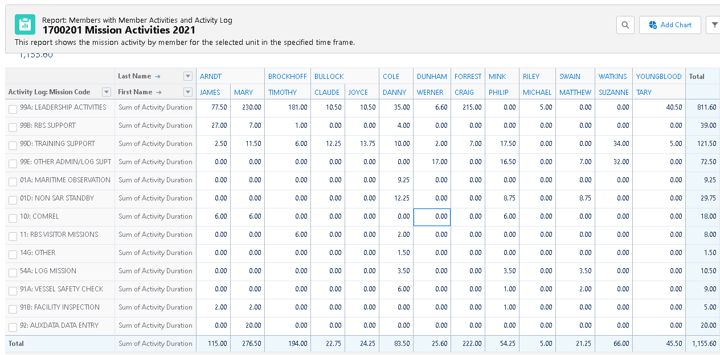

Very respectfully,

Dan Cole

Flotilla Commander

Homer