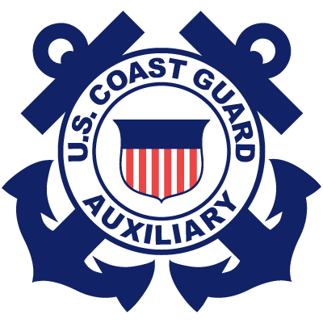
United States Coast Guard Auxiliary
Flotilla 39-10
5801 N. Pulaski, Chicago, Illinois
Meeting Minutes: 9 February 2012 19:30

Attendees:
S. Markle, G. Markle, S. Olson, B. Masters, J. Conte, C. Hillas, M.Parages, and B. Barker.
Call to Order and Pledge of Allegiance
Introduction of guests: Farhan Syed
January Meeting Minutes: Approved and seconded.

Flotilla Commander’s Report
Wilmette Ops Workshop: Saturday, 17 March 2012
1 Hour TCT: (Refresher - To be held during the 17 March Workshop.)
ODUs available: Through Station Wilmette. Please see FC Markle for more information.
Public Affairs Specialist Program: Now available. Volunteers needed.
AUXLAMS Program: (A Leadership Development Program. Fore more information, please contact FC Markle.
Watchstanders Program: Volunteers Needed. For more information, please contact Alan Janney, S.O., Div. 39.
Agenda: Please see FC Markle’s agenda for additional details.

News & Events
VE Blitzes: Dates are under discussion. For info., please contact FSO-VE Hillas or the event calendar.
More Vessel Examiners Needed: We need at least two. For details on training & qualification, please contact C. Hillas.
Vessel Examiner Training: Scheduled for February 25. Please contact C. Hillas, S. Olson, or S. Markle for more information.

Flotilla Staff Officer Reports and Addenda:
FSO-FN: The annual audit is completed. The flotilla is solvent. We are still in the process of changing banks. FC Markle will compose the required letter on appropriate letterhead. J. Conte will determine the choice of bank. Dues are still due.
FSO-HR: J. Conte has contacted prospective members.
FSO-PE: Please see agenda.
FSO-CS: M. Parages is working on the new website. He is importing old information to the new site. He’ll provide a new link.
FSO-VE: C. Hillas ordered more Vessel Safety Check decals. The division needs an inventory of PFDs. Due are still due.

Old Business:
Checking Account: Still in progress. (Ref. FSO-FN report – above.)

New Business:
Vice-Flotilla Commander Election: To fill the position vacated by Ken Dixon, who resigned.
Election Nominating Committee: FC sought the prior nominating committee: (Members: M. Pullman, M. Parages, C. Hillas.)
(N.B. Prospective candidates must submit a letter of intent.)
Proposed Election Date: It was suggested that we hold it at the meeting in March.
Objections Raised: There were several objections from eligible voting members present. Some recommended that we hold the election in April, in order to allow members sufficient time to prepare. It was also recommended that we check our bylaws, in order to ensure that we are following proper election procedures.
Outcome of Discussion: FC Markle said that she would consult with the Division 39 Commander and follow up.
Wilmette OPS Workshop: Scheduled for 17 March.
Wilmette Open House: Tentatively scheduled for 19 May. (Subject to change – due to major events.)
Sector Lake Michigan Operational Planning Directive: Please see the FC’s January notes re: VE training, exams, and blitzes.
Anderson Grants: This program provides funding for needs relating to recreational boating safety, operations, member-training, etc. Proposed Project: The Marlinespike Seamanship Challenge, which was conceived, designed, built, funded, written, promoted, and presented by Brent Barker. Since Brent also wrote the corresponding materials for public affairs, member training, recruiting, and public education, he will share his information with Bob Masters as they work together on the grant proposal.
Lesso Program: M. Parages suggested this unique idea as a valuable opportunity to obtain useful equipment for our flotilla.
He will research the program and provide follow-up information.

Member-Training Session:
FSO-MT Brent Barker presented a training session on Communications. For details, please read the February newsletter.
B. Barker will complete the required 7030 form.

Motion to Adjourn:
Seconded.

