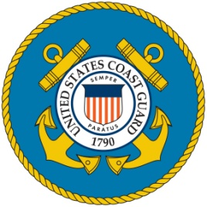
Commander Howard K. Vacco 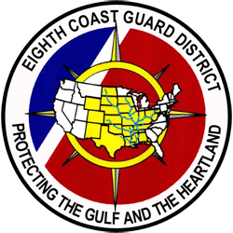
Director of the Auxiliary
District Eight Coastal Region
Commander (CDR) Vacco assumed his role as Director of the Auxiliary, District Eight (D8) Coastal Region in September of 2023. His responsibilities include leading over 1200 Auxiliary personnel, 61 flotillas, and 129 surface and 10 air assets for the D8 Coastal Region. He provides logistical and training mission support of recreational boating safety, search and rescue operations, marine safety and pollution response, as well as emergency management. He additionally conducts outreach with federal, state, local, and tribal partners in support of upholding and enforcing recreational boating safety laws and regulations.

CDR Vacco began his U.S. Coast Guard career in October of 1997. After attending boot camp in Cape May, NJ, he was assigned as a Fireman onboard the USCGC MATAGORDA (WPD 1303), in Miami, FL. In September of 1998, he attended Yeoman (YN) “A” School in Petaluma, CA, and was assigned to U.S. Coast Activities New York, NY. In November of 1999 he served in the Administrative Division at U.S. Coast Guard Air Station Clearwater, FL. After a brief four-month assignment to Integrated Support Command in Miami, FL, he was selected and reported to U.S. Guard Officer Candidate School (OCS) in New London, CT in November of 2003.

After being awarded his commission from OCS, his assignments included: Marine Inspector and Domestic Port & Facilities Assistant Branch Chief at Marine Safety Office Buffalo, NY from 2004 to 2008; Marine Inspector and Domestic Branch Chief at Sector Jacksonville, FL from 2008 to 2011; Coast Guard Civil Rights Equal Employment Opportunity Advisor at Alameda, CA from 2011 to 2014; Vessel Traffic Services Director at New Orleans, LA from 2014 to 2016; Waterways Management Division Branch Chief at New Orleans, LA from 2016 to 2018; Vessel & Port Facilities Inspections and Investigations Staff at U.S. Coast District Eight in New Orleans, LA from 2018 to 2019; and an International Port Security Liaison Officer at Activities Europe located in Brunssum, Netherlands from 2019 until 2022.

CDR Vacco’s personal awards include: The Coast Guard Meritorious Service Medal, two Coast Guard Commendation Medals, four Coast Guard Achievement Medals, four Coast Guard Commandant’s Letter of Commendations Ribbons, The Department of Transportation Secretary’s Award for Outstanding Achievement, four Humanitarian Service Medals, the Military Outstanding Volunteer Service Medal, and numerous service awards.

CDR Vacco is a native of Philadelphia, PA, and now resides in the Tampa, FL area with his wife, Corina, and two sons, Miles and Jude.

