**DEVELOPING THE FUTURE LEADERS OF THE UNITED STATES COAST GUARD THE US COAST GUARD ACADEMY - THIS IS COLLEGE EXCEEDED!**

**By JeanneMarie C. McNamara, PA1 Former Director of Student Programs, USCG Auxiliary**

Do you love the Coast Guard? Do you love to make a difference in the lives of young adults of high school age? If you answered yes to both of these questions, then the Coast Guard Auxiliary has a job for you!

The United Stated Coast Guard Academy (USCGA) in New London, CT is one of the five federally funded US Service Academies. The others include the US Military Academy (USMA) at West Point, NY, the US Naval Academy (USNA) in Annapolis, MD, the US Air Force Academy (USAFA) in Colorado Springs, CO and the US Merchant Marine Academy (USMMA) at Kings Point, NY. While the other Federal Service Academies (FSA) require a congressional nomination for appointments, the USCGA does not require a nomination. While USCGA is the smallest of the five FSAs, it does offer ten academic majors in order to meet the varied missions of the Coast Guard.

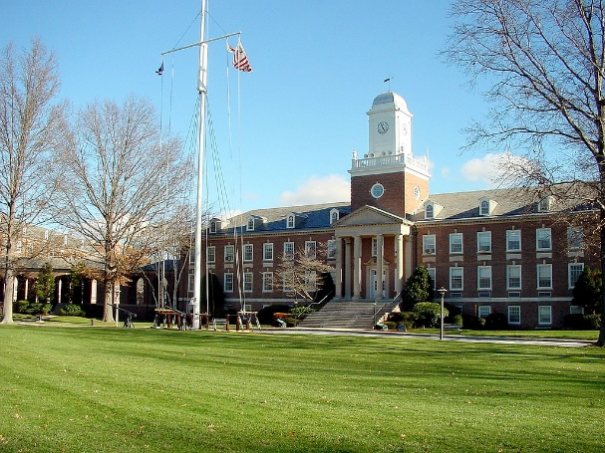

**USCGA New London, CT., Spring 2024. Hamiliton Hall faces the parade field where daily command operations take place.**

USCGA accepts young men and women of excellent character, high academic and athletic ability with strong leadership skills to become the future officers of the Coast Guard. Since a nomination is not part of the application process, acceptance to the Academy is totally merit based, which can actually make acceptance even more difficult than the other FSAs. As with the other FSAs, the schools are tuition free, therefore acceptance is like receiving a half-a-million-dollar scholarship for college. Upon graduation you are then commissioned as a Coast Guard officer and must serve the CG on active duty for a minimum of five years. The other FSAs have a five-year active and three-year reserve minimum commitment upon graduation.

**As a First Class, Cadets may be selected for various leadership positions including the Battalion Staff!**

The students are known as cadets while attending the academy. They pursue a broad core curriculum with heavy emphasis in science, technology, engineering and math (STEM) related subjects. All students graduate with a Bachelor of Science degree. Admission is highly competitive. CGA is a highly structured military environment with a wide range of academic programs and competitive athletics. Their current areas of concentration include ten specialties. They are Civil and Environmental Engineering, Electrical Engineering, Cyber Systems, Interdisciplinary Engineering, Mechanical Engineering, Naval Architecture and Marine Engineering, Operations Research and Data Analytics, Marine and Environmental Sciences, Management and finally, Government.

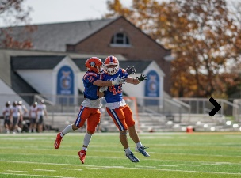

**USCGA Cadet life – Chemistry lab and Fall Football (NCAA – Division 3).**

***Academy Introduction Mission***

CGA offers a week-long summer program called the [Academy Introduction Mission](https://uscga.edu/aim/) (AIM) for rising high school seniors. It is one of the most challenging and rewarding opportunities a high school student can attend. It gives them a chance to experience the life of a U.S. Coast Guard Academy Cadet. Students participate in a one-week summer program that challenges their self-discipline, physical stamina, commitment to service, and capacity for teamwork. They attend classes, do physical training, learn to march in formation, go sailing, sleep in the dorms and eat in the Cadet Mess Hall. They also get to see the Coast Guard in action by observing rescue swimmers and small boat operations. The AIM Program is one of the U.S. Coast Guard Academy’s largest recruiting efforts. Approximately 600 of the most qualified high school students are selected to attend the AIM Program annually. Each applicant must be a U.S. citizen and be from 16 to18 years of age when attending the program. An applicant must be in good health and good physical condition, and be able to run, and perform strenuous exercise, all in the Connecticut summer heat and humidity. There are four AIM sessions (3 in-person and 1 virtual), from which to choose, all set in the month of July.

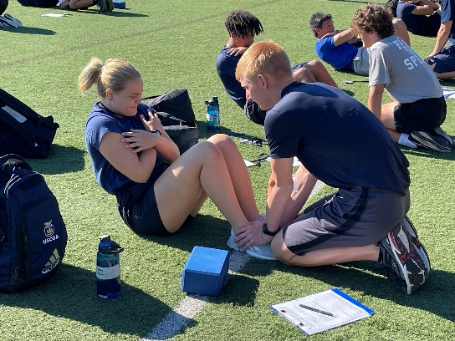

**USCGA, New London, CT. July 2024. AIMSTERS (rising HS seniors) taking the Candidate Fitness Assessment during Week 3 of AIM.**

***Who are Auxiliary Academy Admissions Partners (AAAP)?***

Academy admissions partners are volunteers for the United States Coast Guard Academy Admissions Office from the CG Auxiliary. They recruit, interview, and assist in recommending candidates for admission. Auxiliarists comprise 25% of the total Admissions Partner group. Other partners come from the graduate pool, current active duty, reservists and retirees, the parents’ clubs of the cadets and other interested parties who want to assist the academy in a meaningful way.

Partners attend college fairs and congressional-sponsored service academy events. They also present Coast Guard Academy appointment certificates at graduation ceremonies. In addition, partners are involved in our outreach program making visits to high school guidance counselors, math teachers, science teachers, coaches, civic organizations and community youth organizations. Partners visit prospective cadets and their families, either in-person or virtually to share information about the Academy's admissions process and the student experience. They also conduct interviews with qualified applicants in their local area. All these venues present excellent opportunities for Partners to serve as representatives and good will ambassadors for the Academy.

**San Antonio, TX, Fall 2022 Auxiliarists Jeanne McNamara and Alex Shapovalov (l-r, royal blue shirts) were assisted by CGA graduate R. Gutierrez at one of the largest college fairs in the Central Texas area.**

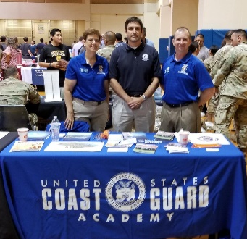

Once they complete their training, partners are issued a “Partner” polo and an official name tag. Partners who are auxiliarists are also issued the “Badge” to wear on their trops or other dress uniforms as long as they remain active in the program.

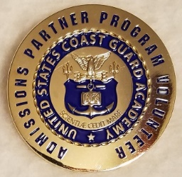

**Pictured above is the Auxiliary Partners Badge.**

Selected Partners assist the Active Duty and Reserve Coast Guard personnel during each of the AIM Weeks. They help by standing watches in the Operations Center; assisting engineering sessions, acting as duty drivers, and assisting as needed elsewhere.

***How to become an Auxiliary Academy Admissions Partners (AAAP)?***

Members interested in becoming an Auxiliary Academy Admissions Partner should visit  
[**www.uscga.edu/partners**](https://www.uscga.edu/partners). Click on STEPS TO BECOMING AN ACADEMY ADMISSIONS PARTNER and you will be guided through the application process. If there is a need in your area and you become qualified through online training, you may be selected to be an official partner.

Like other certifications and qualifications in the auxiliary, once certified, the Auxiliary Academy Admissions Partners are required to complete 4 events (college fairs, interviews, high school visits or congressional academy information days) or at least 20 hours of service to the academy annually to retain the qualification. A record of your events must be corroborated by submitting reports through the Academy's Portal known as the Bear's Den ANDrecording of worked hours/events in Aux Data II.  Applicants must have the membership status of BQ (Basically Qualified) or AX (AUXOP) status to apply for an Auxiliary Academy Admissions Partner. Service hours are entered into AUXDATA II as code 90A with the OPCON of the Coast Guard Academy. Partner hours actually performed at the academy at the AIM program are entered as code 09. Questions about entering hours can be answered by your FSO-IS officer or the National Staff Branch Assistant in the S-Directorate (Student Programs) for Academy Partner Development in your region.

REFERENCES:

<https://wow.uscgaux.info/content.php?unit=s-dept&unit=S-DEPT&category=academy-partners>

<https://uscga.edu/>

Photos: USCGA photographer Paul Duddy or Aux JeanneMarie C. McNamara