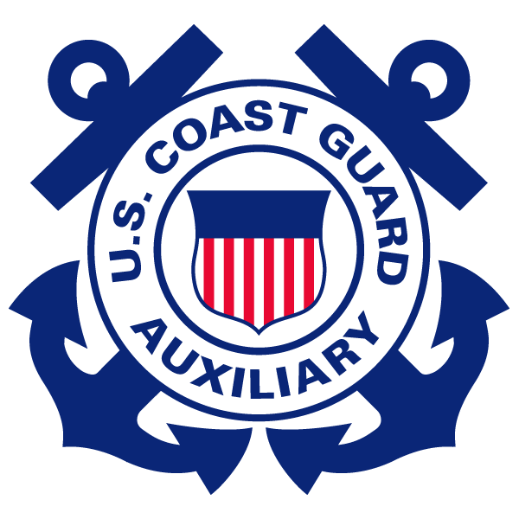
“SEMPER PARATUS”
LEE WENNER PARK, COCOA, FLORIDA

FLOTILLA 17-6

MARCH 2016 NEWSLETTER

Meeting: March 7, 2016, Lee Wenner Park building. Social at 1800, meeting at 1900. Recommended uniform is Tropical Blue with authorized awards and decorations.
Fellowship Event: Anyone who attended the premiere of The Finest Hours should record their time on a 7029 under 99E. Fellowship Events are not to be recorded as missions.
Training Opportunities: March 7th - Annual Team Coordination Training (TCT) Workshop - If you want to continue to participate in USCG Auxiliary Operations and are not new to Operations, this is a mandatory workshop. It will be conducted immediately following the monthly Flotilla meeting, and is a 1 ½ hour course. There is NO online workshop. You must attend this workshop to participate in Auxiliary surface operations in 2016.

March 26th – New Member Training at Station Port Canaveral. There will be a tour of Station Port Canaveral as well as a chance to buy uniforms, insignia items, etc. Uniform is ODU or Tropical Blue. Any questions, please contact Eustace King.

April 23rd - New Member Training – 8 mandated Training Classes at our Flotilla building. Civilian clothes are okay. Any questions, please contact Eustace King.

Public Affairs:
As Spring arrives, more and more of our neighbors will be thinking about new boats, new fishing equipment, and all things water borne. As part of the Spring revival, the flotilla is participating in several boat shows and nautical themed events. YOUR HELP IS WANTED AND NEEDED. The first two events on our calendar are the Harbortown Marina Nautical Flea Market, April 2-3, and the Coastal Angler Magazine show at the Boaters’ Exchange on April 9. We need flotilla members from 10 am until 6 pm on both April 2nd and 3rd, and then from 8 am until 5 pm on April 9. Bill Strawn will bring a sign-up sheet to the March 7th Flotilla Meeting, but if you are unable to attend, please send him an email at billstrawn82@gmail.com with the times you can help.

These shows are perfect examples of how we can get information on boater safety and our safety classes to the public, and just as importantly, recruit new members. Please look at your schedule and pencil in 2-4 hours when you want to give back to the community. Below is a copy of the April 2 and 3 sheet to show you when we need you.

TIME | VOLUNTEER ONE | VOLUNTEER TWO | VOLUNTEER THREE
2-1000-1200
1200-1400
1400-1600
1600-1800
3-1000-1200
1200-1400
1400-1600
1600-1800
9-0800-1000
1000-1200
1200-1400
1400-1600
1600-1800

Boater Safety Courses: The Flotilla’s PE program now includes Suddenly in Command (SIC) and Paddlesports America (PSA). The Flotilla’s website has been amended to reflect when and where the two new PE courses will be taught. Please refer questions to Eustace King.

Eustace King and Dan McIntyre visited West Shore High School where they set up a table during lunch time and distributed PE-related pamphlets, flyers, etc. They also discussed boating safety training opportunities with the students.
The February 20, 2016 ABS course held at the Flotilla building graduated 20 students!
Diversity: Diversity in the USCG has been a long standing, ongoing mission. February 3, 1976, the USCG Academy became the first federal service academy to offer an appointment to a woman. In the Class of 1980, three women were appointed along with 47 male cadets. Linda Johansen, Class of 1980, was the first female Regimental Commander of the USCGA.
Future Events: The Flotilla has two big items in the works. We want to begin one of the tasks in Operation Excellence, training with the Coast Guard in the ocean, and also perform an ocean tow in preparation for the Offshore Boat Races, Thunder on Coca Beach May 14th and 15th. More information will be sent out as it becomes available.
Station Port Canaveral is having a Coast Guard Reunion on April 9th. If you are interested in participating, please contact Jack Miller.
The finalized schedule of Aviation Workshops is listed below. These are invitation only events. Please contact your Auxiliary Air Coordinator at the respective air station.
April 1st-2nd - Savannah; Miami - April 9th-10th; Clearwater – April 15th-16th; Borinquen, PR – May 14th-15th.
Station Port Canaveral: Station Port Canaveral is always in need of USCG Auxiliary personnel to act as Gate Guards, and if qualified, as Radio Watchstander, or Auxiliary Chef. If you are interested or wish to know how to become qualified, please contact FVC, Donna Miller.
Volunteers Needed: Volunteers are needed to be flag bearers for the March 5, 2016 commemoration of the Last Naval Battle of the American Revolution at the Veterans Memorial on Merritt Island. Volunteers only need to walk a short distance carrying a flag. Please contact Bill Giers if you are interested.

