“SEMPER PARATUS”
LEE WENNER PARK, COCOA, FLORIDA

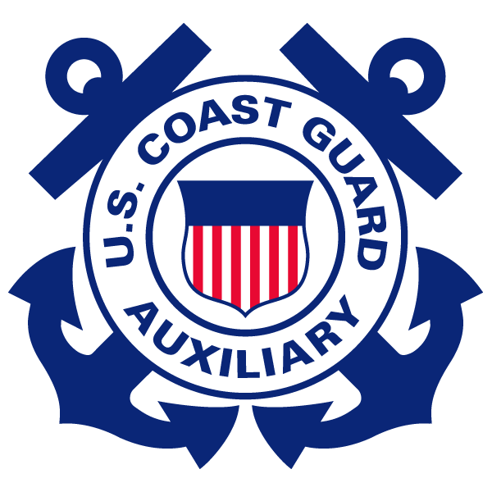

FLOTILLA 17-6

JANUARY 2016 Newsletter

JANUARY 2016 NEWSLETTER

Meeting: January 4, 2016, Lee Werner Park building. Social at 1800, meeting at 1900. Please, everyone should try to be in proper Tropical Blue Long uniforms with all authorized awards and decorations for the January meeting. Jimmy will be taking photos up by the flags.
Facility owners: Please get a photo of their facility to FC John Kachenmeister. This includes both boats and communications facilities. Ideally, photo is of the facility underway with USCG Auxiliary patrol boards and ensigns displayed, but he will accept what you have available. We will display the photos in our building.
Building: We have signed a new temporary use agreement carrying us through March 2016 while the lawyers work things out.
Operations: January 23rd will be a busy day. We have an air-surface search mission in the final planning stages. This will involve multiple boats, one AUXAIR asset, and active duty USCG personnel from their operations section. There are crew positions still open if you want to participate. Action officer is Joe Peake, Operations. Please contact Joe to participate.
ABS Instructor Workshop: There is also an instructor workshop sponsored by FWC in Ft. Lauderdale on January 23rd. Action officer is Eustace King, Public Ed. He is trying to arrange a car pool for this one-day seminar. Please contact Eustace if you would like to attend.
Facilities: Three (3) facilities are coming due for their annual inspections: Joe Peake’s, Bob Dicicco's and Roger Bonnett's. Action officer to coordinate renewal inspections is Jonathan Urdanetta, Vessel Exams.
Instructors: About Boating Safety Class is on Jan 16th. Instructors have already been selected for the first 3 months. If you are an instructor and have not contacted Eustace King, please do so immediately to get on the next schedule.

Boating Safety Classes: About Boating Safety classes are each month on the third Saturday of the month.
Station Port Canaveral: Station Port Canaveral is always in need of USCG Auxiliary personnel to act as Gate Guards, and if qualified, as Radio Watchstander, or Auxiliary Chef. If you are interested or wish to know how to become qualified, please contact FVC, Donna Miller.

Coast Guard Day: Coast Guard Day is August 4, 2016. This is the annual celebration of the founding of the Coast Guard’s predecessor service, the Revenue Marine by Alexander Hamilton, Secretary of the Treasury, and Congresses approval of the first 10 revenue cutters. This is a family day for active personnel at the Station. Auxiliary volunteers are always needed to help plan, setup and celebrate. Donations of funds and equipment are always welcome. Put it on your calendar.

