Tri-Community Volunteer
Fire District

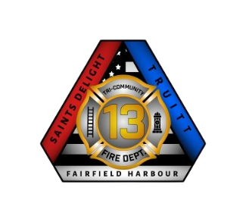
May 28, 2025

Dear Jeff Cunniff,
Per our conversation on May 28th, I am writing this letter to provide you written authorization to store equipment from the Coast Guard Flotilla in the fire department’s storage shed located outside the Fairfield Harbour Fire Station. No illegal, hazardous, or flammable materials may be stored in the shed. Multiple agencies store their equipment there so all stored items must be stored in a neat and orderly fashion to allow the other agencies access to their equipment.
If you need any additional information or assistance, feel free to contact me on my cell number at (303) 514-6730.

Sincerely,
Mario T. Rebello Jr., Deputy Chief
Tri-Community Volunteer Fire Department
200 Saints Delight Church Rd.
New Bern, NC 28560
Mobile: (303) 514-6730
Email: mario.rebello@tcvfrd13.org

