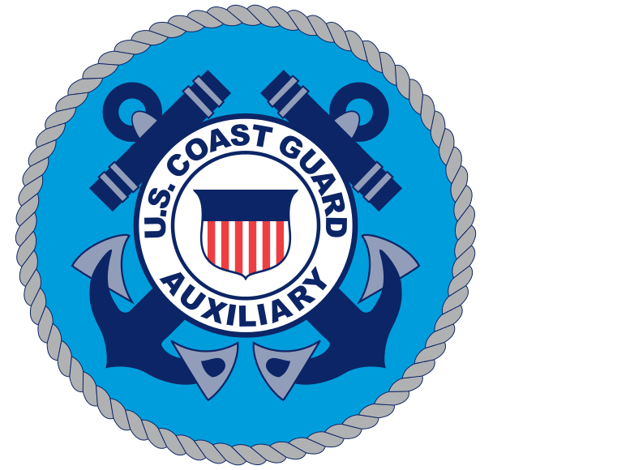

**US COAST GUARD AUXILIARY FLOTILLA 15-08**

***ABOUT BOATING SAFELY* COURSE SIGN UP**

***Saturday May 9, 2020***

***0800-1600***

|  |  |  |
| --- | --- | --- |
| **NAME** | **EMAIL ADDRESS** | **PHONE NUMBER** |
|  |  |  |
|  |  |  |
|  |  |  |
|  |  |  |
|  |  |  |
|  |  |  |
|  |  |  |
|  |  |  |
|  |  |  |
|  |  |  |
|  |  |  |
|  |  |  |
|  |  |  |
|  |  |  |

**FOR MORE INFORAMTION VISIT:**

[**HTTP://a0141508.wow.uscgaux.info**](HTTP://a0141508.wow.uscgaux.info)

**Or**

[**www.cgaux.org**](http://www.cgaux.org)