**BTV Flotilla 15-02, 1SR**

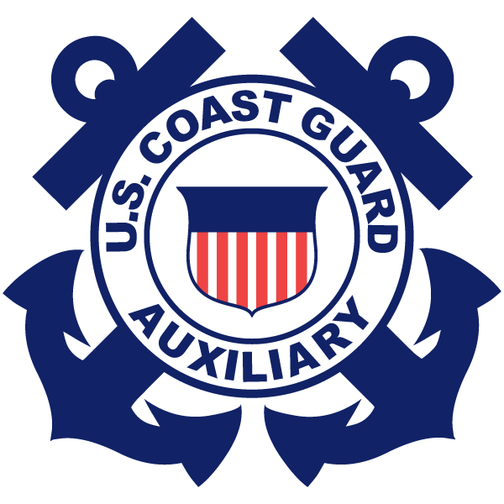

Volume 18, Issue 18 October 2020

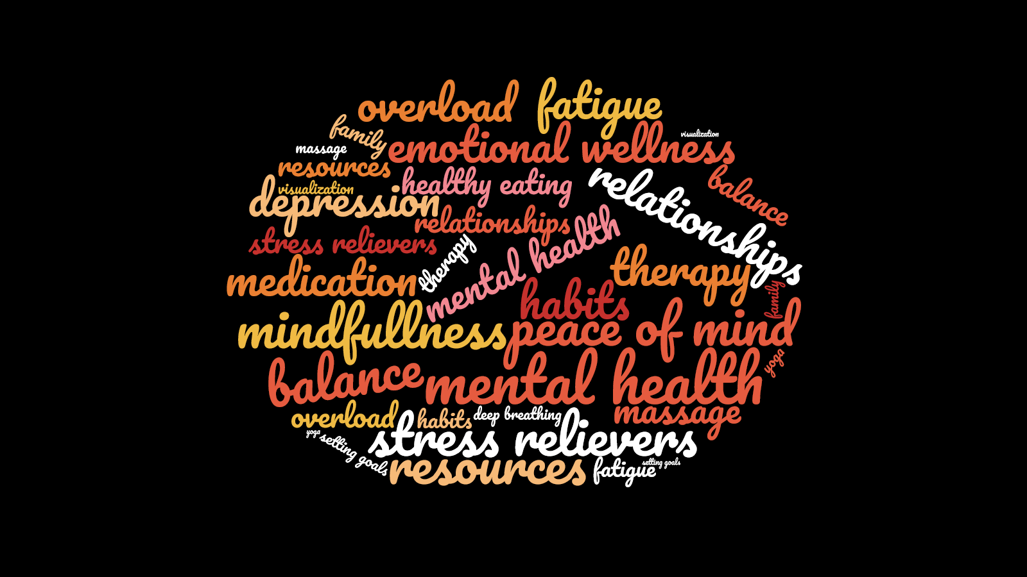

<https://mentalhealth.vermont.gov/>

Each of us has health and well-being. To flourish we must take our mental health into account. As the World Health Organization (WHO) says, “there is no health without mental health.”

According to the World Health Organization, “Health is a state of complete physical, mental, and social well-being and not merely the absence of disease or infirmity. Mental health is an integral part of this definition.”

The encouraging news is we can strengthen our mental health and well-being. We can lower our stress levels and increase our ability to deal with challenges. This also improves our physical health.

We know, for example, that how we care for our children as they grow impacts their later health and well-being. We also know that connection with others who may be going through a difficult time can make a big difference.  It’s important to know that we all, at some point in our lives, experience mental health challenges. There are effective treatments and interventions that can help us regain our mental health and wellness.  And for those of us who live with mental illness, recovery is possible.

For more information on preventing mental illness and strengthening health and wellness, go [here.](https://mentalhealth.vermont.gov/prevention-and-promotion) For information on treatment and services go [here](https://mentalhealth.vermont.gov/individuals-and-families/designated-and-specialized-service-agencies). If you are in need of immediate help see the numbers [in the graphic above].

**______________________________________**

## 4 Key Points to Discuss with Boaters:

## Always Wear It

1. **Take a Boating Safety Course**
2. **Get a Vessel Safety Check**
3. **Don’t BUI**



**Wear It! Inflatable Life Jacket Education video**

[**https://www.youtube.com/watch?v=VFEDdkhZuAg&feature=email**](https://www.youtube.com/watch?v=VFEDdkhZuAg&feature=email)

Editor: Ruth Ring, FSO-PB, 15-02, 1SR.

[ruth_ring@msn.com](mailto:ruth_ring@charter.net)

Submit articles/photos NLT 2 weeks

prior to the next meeting, or as directed.

October is Emotional Wellness Month

<https://familydoctor.org/mental-health-keeping-your-emotional-health/>

* Be aware of your emotions and reactions
* Express your feelings in appropriate ways
* Think before you act
* Manage stress
* Strive for balance
* Take care of your physical health
* Connect with others
* Find purpose and meaning
* Stay positive

***If anyone is struggling with isolation and needs to talk with someone, please reach out to the flotilla leadership. We are all in this together.***

***FC Robert White***

|  |  |  |  |
| --- | --- | --- | --- |
| Inside This Issue | | | |
|  | | **1** Emotional Wellness Month  **2** Calendar of Events/Open Flotilla Positions | |
|  | | **3** Meet Your Flotilla Staff | |
| **Burlington VT Flotilla 15-02, 1SR**  **Flotilla Commander: Robert T. White**  **Flotilla Vice Commander: Bob Bernier**  **Human Resources Officer: Kenneth Watt**  <http://wow.uscgaux.info/about.php?unit=014-15-02>  <https://www.facebook.com/US-Coast-Guard-Auxiliary-Flotilla-15-02-Burlington-VT-351235695499189/> | |  | |
|  | |  | |
|  | |  | |

**Open Flotilla Positions**

**FSO-IS Information Systems Officer**

**FSO-MS Marine Safety & Environment Officer**

Please volunteer for one of the positions listed above. You will learn a lot, help the flotilla function more effectively, and receive help from other knowledgeable members when needed.

To read the general job descriptions for these positions, check out this link posted by another unit: <http://wow.uscgaux.info/content.php?unit=130-05-02&category=staff-officers>

***\*\*\* Division 15 Change of Watch (COW) \*\*\****

Saturday, 14 November 2020 at 1300

VIRTUAL DELIVERY VIA ZOOM

Uniform is Tropical Blue Long, Service Dress Blue,

or appropriate civilian attire.

Please contact Ms. Lynn Enny at [glanenny@aol.com](mailto:glanenny@aol.com)

by 6 Nov 2020 to affirm your attendance.

Calendar of Events

No in-person meetings scheduled at this time

**Clove Hitch – Rope End**

[**https://www.animatedknots.com/clove-hitch-knot-rope-end**](https://www.animatedknots.com/clove-hitch-knot-rope-end)



Official Vermont Boating Safety Course Online

[**https://www.boat-ed.com/vermont/**](https://www.boat-ed.com/vermont/)

__________________________________________

**Have you submitted your 7029/7030?**

**Each member should submit one monthly.**

|  |  |
| --- | --- |
| **Flotilla 15-02:**  **Meeting Location:** | U.S.C.G. Station Burlington  1 Depot Street  Burlington, VT 05401 |
| **Meeting Time:** | 1st Wednesday of each month  at 19:00 hours (7 p.m.) |
|  |  |

CONFIDENTIALITY NOTICE – PRIVACY ACT OF 1974

Disclosure of this material is subject to provisions of the Privacy Act of 1974. This Act, with certain exceptions, prohibits disclosure, distribution, dissemination, or copying of any material containing home address, home telephone number, spouse’s names, and social security numbers, except for official business. Violations may result in disciplinary

action by the Coast Guard and/or civilian criminal sanctions.



# Meet your Flotilla 15-2 Staff

Elected Officers

* FC Flotilla Commander - Robert Thomas White
* VFC Vice Flotilla Commander - Robert “Bob” John Bernier
* IPFC Immediate Past Flotilla Commander - Richard “Rick” A. Moore

Flotilla Staff Officers

* FSO-CM Communications - William “Bill” D. Rowe
* FSO-CS Communications Services - Robert Thomas White (also SO-CS)
* FSO-DV Diversity - Karleen “Kris” I. Teply
* FSO-FN Finance - Alan L. Nye
* FSO-HR Human Resources - Kenneth Lee Watt
* FSO-MA Materials - Dan B. Couture
* FSO-MT Member Training - Alan L. Nye
* FSO-NS Navigation Systems - Alan L. Nye
* FSO-OP Operations - Alan L. Nye (also SO-OP)
* FSO-PA Public Affairs - Karen L. Weber
* FSO-PB Publications - Ruth A. Ring (also BA-UCWD)
* FSO-PE Public Education - Karleen “Kris” I. Teply
* FSO-PV Recreational Boating Safety Visitor Program - Richard “Rick” A. Moore
* FSO-SR Secretary/Records - Mary Annette Cox (also BC-HRS)
* FSO-VE Vessel Examination - Robert “Bob” John Bernier (also SO-MA)

As you look at the list above, you might notice that some flotilla members are carrying two, three, or even four flotilla jobs. Some members are also carrying division or national jobs. That can be a heavy burden. If you have interest in any of the above positions, or the ones that are not currently filled (FSO-IS Information Systems Officer, FSO-MS Marine Safety and Environment Officer), please approach the member holding the position, or the FC/VFC, and let them know. You might consider starting out as an assistant, initially, to see if it’s a good fit, while gaining experience with a knowledgeable mentor. For a description of the staff officer duties, please check out this link: <http://wow.uscgaux.info/content.php?unit=114-06-02&category=officer-job-details>

Note: At our last flotilla meeting, Bob Bernier was elected to be the new FC, and Alan Nye the new VFC for 2021. Congratulations to them both!!