**05-03 REPORT TO DIVISION for July 2nd, 2018 Meeting**

|  |
| --- |
| **Immediate Past Flotilla Commander (IPFC)**: *Tony Carter* – [acarter616@aol.com](mailto:acarter616@aol.com) |

|  |  |  |
| --- | --- | --- |
| **Communications (CM):** *Stephen Harwood / Zach Perkins* | **Marine Safety (MS)**: *Bill Jefferson / open* | **Secretary and Records (SR)**: *Andrea Bray / open* |
| **Communication Services–website (CS*)****: Stefan Jacome-Ramos / Avi Mayer* | **Member Training (MT)**: *Mark Dilone / open* | **Vessel Examinations (VE)**: *open / Andrew Thurman* |
| **Diversity (DV)**: *Bert Ongkeo / open* | **Navigation Systems (NS):***Andrew Thurman / Bill Jefferson* | **Rescue & Survival Systems:** *Andrew Thurman / open* |
| **Finance (FN)**: *Chad Goldman / open* | **Operations (OP):** *Bill Jefferson / open* | **JJCCJ AUP Detachment Leader:** *Susan Pickman* |
| **Food Services (FS):** *Bert Ongkeo / open* | **Public Affairs, social media (PA)**: *Zach Perkins / open* | **Audit/Budget Committees**: *Ashish Rajadhyaksha, Chair, Tony Carter, Richie Scher* |
| **Human Resources (HR)**: *Sandro Sherrod / open* | **Publications (PB):** *Stevie White / open* | **Emergency Preparedness Committee Chair:** *Ashish Rajadhyaksha / Dennis Piedra* |
| **Information Services–AUXDATA (IS)**: *Bill Jefferson / open* | **Public Education (PE):** *Juan-Carlos Sobrino / open* | **Fellowship Committee Chair:** *Sandro Sherrod / open* |
| **Materials (MA)**: *Cristin Buiciuc / open* | **Program Visitor (PV)**: *Joy Scher / open* | **Test Proctor**: *Andrew Thurman* |

**What’s happened since last Division meeting:**

* Flotilla membership numbers 117, with 3 new members joining in the past month. 21 officers and assistants manage the Lower Manhattan Flotilla.
* Andrew Thurman and Bill Jefferson to be awarded RBS Device for significant Auxiliary RBS contributions in 2017 and 2018, joining Tony Carter in this award.
* Bill Jefferson establishing connections for District Aux-Build with Sector NY, eg joining Ribbon Cutting Ceremony at Sandy Hook Station July 3.
* Stephen Harwood is preparing flotilla for Aux-Telecom event: Coast Guard Auxiliary Special Event Radio Day, October 20th - register by September 15th, POC Dan Amoroso: w3di@arri.net. He has also provided radio comms training to Village Community Boat House with assistance of Juan Carlos Sobrino in late May.
* Juan Carlos Sobrino, with assist from Allan Peda, gave a well attended ABS class at the HRPT facility mid-June.
* Bert Ongkeo reports extensive FS activities throughout May, including service aboard the Katherine Walker, Staten Island Welcomes Our Heroes, Fleet Week service aboard 3 CG cutters (close to 1,000 meals), and the CG Culinary Symposium - Admiral's challenge coin awarded to Aux-FS attendees.
* Lower Manhattan Flotilla still awaiting its National Diversity award.
* John Jay Detachment has received a donation of ODU's from the CGAUX Association - Division members please see Alex Rivas if interested in securing a free set; note available sizes below:

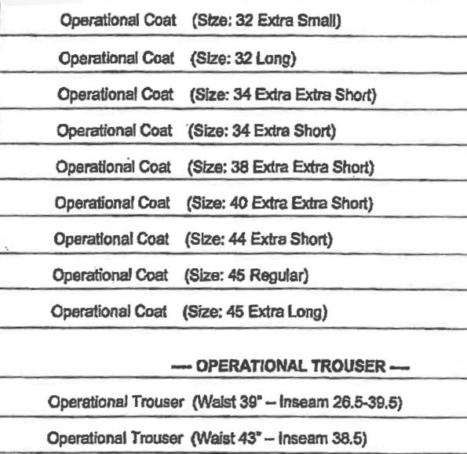

**Upcoming Events:**

* Results of National FC Survey - when available?
* Continue to book 7030 operations hours in Surface and AuxAir patrols this summer, and provide training to interested members. AuxAir observer training led by Mario Abruzzi.

**Status of Long Term Goals:**

* Quals and Training: Our strong RBS presence including PE, FS, MS, and PA competencies need to be further leveraged with the membership: 4 new VE's trained in May.
* New Member Quals: nothing new to note this period.
* Increasing number of FSO assistants remains a priority.

**What Help is Required and From Whom**

* Full day MANTR training session and AuxOp courses desirable, e.g., weather, advanced coastal navigation, AuxCom, TCO.

**End of Report**