When to use; where the search area is small but the last known position is not so well known, the SAR pattern most likely to be used is the “Expanding Square” pattern
Expanded Square Search
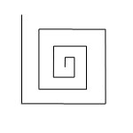
Leg 1 - Downwind for 1 leg
Leg 2 – 90 degree starboard turn for 1 x length

Leg 3 – 90 degree starboard turn for 2 x lengths
Leg 4 – 90 degree starboard turn for 2 x lengths

Leg 5 – 90 degree starboard turn for 3 x lengths
Leg 6 – 90 degree starboard turn for 3 x lengths

Leg 6 – 90 degree starboard turn for 4 x lengths
Leg 7 – 90 degree starboard turn for 4 x lengths

Leg 8 – continue pattern

================================================================
Parallel Search Pattern
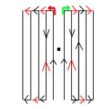
With this search it can be done with 1 or more vessels
The main vessels starting the search are the two back arrows next to datum (Black square)
They will go up past datum and after a certain distance will turn away from each other at 90 degrees
then at very short distances on this track will turn and go parallel to each other on reciptical courses
they will do this until told to stop

When to use; when the search area is small (a bay, for example) and the last known position is well known, the search pattern is called “vector search”

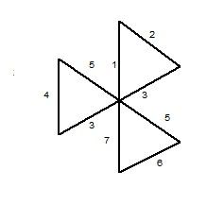

Start with Set & Drift for first leg
Leg 1 - Downwind for 1 leg – Turn starboard 130 degrees
Leg 2 – 1 length – turn starboard 130 degrees

Leg 3 – two lengths – then turn starboard 130 degrees - Aim for DATUM
Leg 4 – one length – turn starboard 130 degrees
Leg 5 – two lengths – then turn starboard 130 degrees - Aim for DATUM
Leg 6 – one length – turn starboard 130 degrees
Leg 7 – one length - back to Datum - Aim for DATUM

