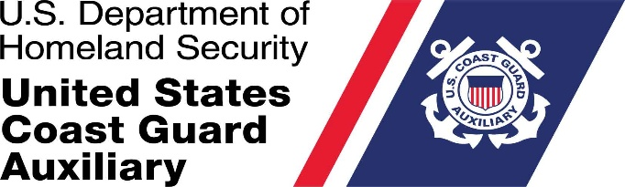

M e m o r a n d u m
DAY MONTH YEAR

From: Matthew Dillon, DNACO
Atlantic East Area

To: Sean Peoples, Director
Administrative Investigations Directorate
U.S. Coast Guard Auxiliary

Subj: REQUEST FOR INVESTIGATION

Ref: (a) U.S. Coast Guard Auxiliary Manual, COMTINST M16790.1G
(b) Coast Guard Administrative Investigations Manual, COMDTINST M5830.1A

1. A Request for Investigation (RFI) was received alleging that Auxiliarist Roger Rabbette, Flotilla 7-11, City, State, violated Coast Guard or Coast Guard Auxiliary policy.

2. The basic allegations are that ***PERSONS NAME*** engaged in a pattern and practice of interacting with fellow members of the Auxiliary ***STATE BREIFLY THE REASON – The CHARGES***.

3. Following my review of same, I have determined that an investigation is warranted.

4. This is to request that you promptly assign one or more members of the Administrative Investigations Directorate to conduct an investigation to determine whether Aux. Rabbette’s conduct violated Coast Guard or Coast Guard Auxiliary Policy.

5. The investigator(s) appointed shall follow the general guidance of Ref (b) as set forth by Ref (a) Section F.3.b, and shall report their findings, opinions, and recommended action to me in no more than 30 (Thirty) days from the date of their assignment.

###

Copy: DLO
ANACO-CC

