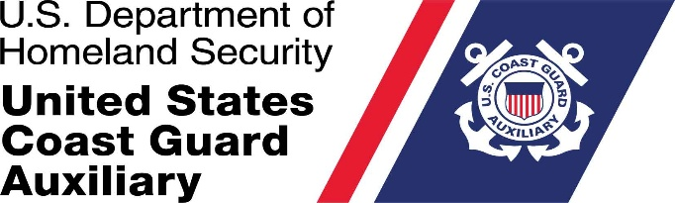

M e m o r a n d u m
DAY MONTH YEAR

From: Commodore/ Position Jack Smith, Office Title
Area or District

To: Name of person who is being investigated

Subj: NOTICE OF INVESTIGATION PURSUANT TO AUXILIARY MANUAL 3.F.3.B.

Ref: (a) Coast Guard Auxiliary Manual COMDTINST M16790.1G

1. I have completed the preliminary review of the allegations of misconduct alleged against you by a member of the National Staff (it can be a position or the name of the individual) dated DAY MONTH YEAR.

2. The basic allegations are that you engaged in a pattern and practice of:

The basic allegations are that you engaged in a pattern and practice of **BRIEF DECRIPTION**

3. I have determined that an investigation is warranted and appointed Sean Peoples, Director of Administrative Investigations, on the DAY MONTH YEAR to conduct the investigation into the allegations and to submit an investigative report containing his conclusions and recommendations to me within sixty (60) days (however you can request it be done in 30 days. However, it’s no longer than 60 days.

4. I am advising you that you have the right to address, in writing, the investigator or investigating committee prior to the investigator or investigating committee’s report to me. You should contact the investigator or investigating committee by e-mail to determine the deadline for submitting your response.

5. The investigator(s) appointed shall follow the general guidance of Ref (b) as set forth by Ref (a)
Section F.3.b, and shall report their findings, opinions, and recommended action to me in no more
than 60 (Sixty) days (however you can request it be done in 30 days. However, it’s no longer than 60 days) from the date of their assignment.

Copy: ANACO-CC or District Legal Officer or both

