News Release
New Paddlecraft Safety Effort Starts at the Water’s Edge

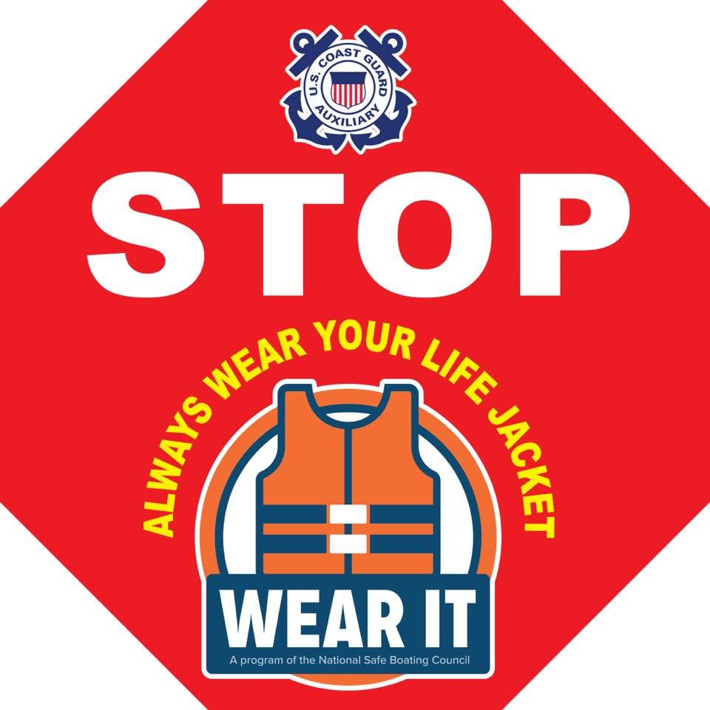

Canoeists and kayakers may soon see a red safety sign posted at launch ramps and other water access areas across the country. The new safety sign is part of an ongoing effort to reduce the number of paddle sport fatalities. USCG Recreational Boating Statistics show that, between 2013 and 2018, an average of 133 paddlers died each year – nearly a quarter of all boating deaths. The vast majority of these paddlers were not wearing a lifejacket and drowned.

The sign resembles a stop sign and carries a simple message - Stop. Always Wear Your Life Jacket. “The purpose of this program is to remind paddlers that the single most important factor in preventing drowning is to wear an appropriate life jacket,” said Robert E. Kumpf, of the Coast Guard Auxiliary.

The Coast Guard Auxiliary, the National Safe Boating Council, the Water Sports Foundation, and regional paddling organizations have worked together to promote paddlecraft safety. For more information about the Coast Guard Auxiliary’s paddlecraft safety programs please visit the Recreational Boating Safety Outreach Directorate's website by clicking the link.

