Fiscal Year 2026 - Quarter 1: October 1 – December 31, 2025
There are no planned CG-BSX-11 funded Auxiliary C-Schools.
Fiscal Year 2026 - Quarter 2: January 1 – March 31, 2026
AUX Course ID | Direct Access Course Code | Course Name | Tentative Start Date | Tentative Stop Date | Students | Instructor | Location
AUX18 | 501574 | AUX AVIATION SPATIAL DISORIEN | Monday, February 2, 2026 | Tuesday, February 3, 2026 | 4 | 1 | FAA Oklahoma City
AUX17 | 501573 | AUX CREW RESOURCE MGT/ORM | Saturday, February 14, 2026 | Sunday, February 15, 2026 | 5 | 2 | Alameda
AUX17 | 501573 | AUX CREW RESOURCE MGT/ORM | Saturday, February 21, 2026 | Sunday, February 22, 2026 | 5 | 2 | Buffalo/Rochester
AUX17 | 501573 | AUX CREW RESOURCE MGT/ORM | Sunday, March 1, 2026 | Monday, March 2, 2026 | 5 | 2 | Caldwell/Farmingdale
AUX17 | 501573 | AUX CREW RESOURCE MGT/ORM | Sunday, March 1, 2026 | Monday, March 2, 2026 | 5 | 2 | Chicago
AUX17 | 501573 | AUX CREW RESOURCE MGT/ORM | Monday, March 2, 2026 | Tuesday, March 3, 2026 | 5 | 2 | Baltimore
AUX17 | 501573 | AUX CREW RESOURCE MGT/ORM | Tuesday, March 3, 2026 | Wednesday, March 4, 2026 | 5 | 2 | Orlando/Miami
AUX17 | 501573 | AUX CREW RESOURCE MGT/ORM | Wednesday, March 4, 2026 | Thursday, March 5, 2026 | 5 | 2 | Cape Cod
AUX17 | 501573 | AUX CREW RESOURCE MGT/ORM | Saturday, March 14, 2026 | Sunday, March 15, 2026 | 5 | 2 | Los Angeles
AUX17 | 501573 | AUX CREW RESOURCE MGT/ORM | Saturday, March 21, 2026 | Sunday, March 22, 2026 | 5 | 2 | Barber's Point
AUX02 | 501061 | AUXLAMS RESIDENT COURSE | Monday, March 16, 2026 | Thursday, March 19, 2026 | 20 | 2 | St. Louis
AUX05A | 501805 | AMLOC ROADSHOW | Monday, March 16, 2026 | Thursday, March 19, 2026 | 20 | 2 | St. Louis

Fiscal Year 2026 - Quarter 3: April 1 – June 30, 2026
AUX Course ID | Direct Access Course Code | Course Name | Tentative Start Date | Tentative Stop Date | Students | Instructor | Location
AUX18 | 501574 | AUX AVIATION SPATIAL DISORIEN | Monday, April 27, 2026 | Tuesday, April 28, 2026 | 5 | 1 | FAA Oklahoma City
AUX06 | 501065 | AUX ATON AND CHART UPDATING | Friday, April 10, 2026 | Sunday, April 12, 2026 | 20 | 2 | Yorktown

Fiscal Year 2026 - Quarter 4: July 1 – September 30, 2026
AUX Course ID | Direct Access Course Code | Course Name | Tentative Start Date | Tentative Stop Date | Students | Instructor | Location
AUX02 | 501061 | AUXLAMS RESIDENT COURSE | Monday, August 3, 2026 | Thursday, August 6, 2026 | 20 | 2 | Orlando
AUX10 | 501548 | INFO SYSTEMS (AUXDATA/AUXINFO) | Monday, August 3, 2026 | Thursday, August 6, 2026 | 18 | 3 | Orlando
AUX12 | 501562 | AUX PUBLIC AFFAIRS & MKT TNG | Monday, August 3, 2026 | Thursday, August 6, 2026 | 20 | 2 | Orlando

*Notes*
- Not all of these FY26 C-Schools have been input into the USCG Direct Access System. As FY26 goes on, the above courses will appear in Direct Access for the DIRAUX Offices and CG-BSX-11 to see. Auxiliarists are not able to access the USCG Direct Access System.
- To apply to one of these C-Schools, submit a Student Training Request (STR) through your respective Auxiliary COLM for it to get to the DIRAUX and then CG-BSX-11 for processing. On the STR, please use your full legal name (no nicknames) to avoid any confusion with people who have similar names. Ensure that the name also matches what is in AUXDATA. Instructors will re-verify REYR statuses, course prerequisite completion, disciplinary status, and overall course availability. Submitting an STR does not guarantee course enrollment, also STR submittance is not first-come-first-serve as admittance is determined holistically. Usually, priority will be given to new students. To ascertain admittance status, students are encouraged to reach out to their COLM and instructors to know if their STR request was entered, or if they were waitlisted/not admitted into the course. Instructors are encouraged to frequently communicate with all applicants to ensure clarity/transparency. Selected students will be informed of their admittance directly from their course instructors once the attendance is finalized in Direct Access.
- Official Direct Access Orders will be created and issued to each student and instructor. These orders will have additional instructions and will be emailed to each attendee from their DIRAUX Office. Attendees are highly encouraged to retain a paper copy of these orders for the duration of their training. Attendees should work with their DIRAUX Offices for assistance with making travel arrangements. In addition to the Direct Access Orders, attendees are highly encouraged to also print a copy of their E2Solutions (ETS) orders and itinerary. At the airport, Auxiliarists should approach the airline’s front desk with a copy of their Official Direct Access and ETS Orders in hand. Doing so should waive up to 5 bags for checking onto the plane. If not, save that receipt.
- Attendees should be proactive in arranging their trip and also finalizing their trip in ETS as soon as possible after the training trip is complete. Otherwise, transportation ticketing may not be available and travel reimbursement may be extremely prolonged. To avoid any delays, it is best to not get locked out of ETS, routinely check one’s ETS account, communicate with one’s DIRAUX Office, and check one’s email for any trip notifications or changes. Ensure one’s ETS and AUXDATA account is accurate, up to date, and accessible.
- Save and keep all receipts! This includes hotel reservations, taxes, fees, transportation, and food. It is highly recommended to take photos of all receipts and email them to yourself. This will save time and make it easier when it comes to getting reimbursed within ETS. Attach all receipts in the ETS system for the training related travel.
- Auxiliary Uniforms must be worn while at these C-schools for both Auxiliary students and instructors. Instructors may decide which Auxiliary uniform may be worn (ODUs/Trops). However, typically, it is the Tropical Blue Uniform.
- If a student is not able to attend the C-school for which they are committed to attending, the student must notify their COLM, instructor, and DIRAUX Office as soon as the student is aware of the conflict. If not, the quota will go to waste and will not be able to be recovered or given to another student for them to attend due to funds already being committed and obligated. It is absolutely imperative that students attend the C-schools they have received orders to. However, grace will be given in the event of flight delays/cancellations, illness, death in the family, natural disaster, or any other extreme situation, etc. Please communicate and notify your COLM, instructor, and DIRAUX Office, so course adjustments may be made and to ensure proper accountability.
- Check the T-Directorate page on the Auxiliary website to learn more about each course’s description and prerequisites.
- These National Auxiliary CG-BSX-11 student and instructor C-school quotas could increase if FY26 funding later becomes available within the USCG FORCECOM Training budget as the year goes on. Additionally, if a DIRAUX Office has funds available, they may work with USCG FORCECOM Training to increase the National Auxiliary CG-BSX-11 quotas.
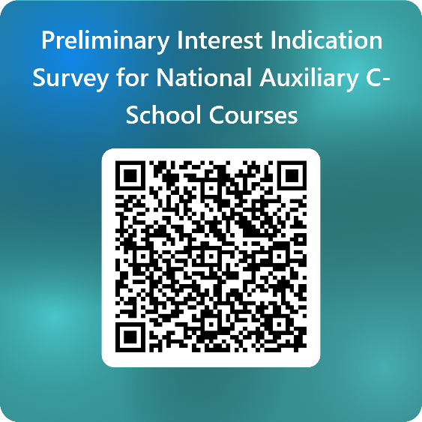
https://forms.osi.apps.mil/r/hdywnFeJWu

