Charting your course in the

UNITED STATES COAST GUARD AUXILIARY

MEMBER INVOLVEMENT PLAN

MAKING CHOICES FOR SUCCESS!

Charting a course creates success for the United States Coast Guard Auxiliary missions and programs, while providing satisfaction and pride by our members.

This booklet of planning is designed as a working document to be maintained for support of our member’s involvement. We look forward to your active involvement in Auxiliary activities.

DEPARTMENT OF HUMAN RESOURCES (REV. 12/16/10)

USCG AUXILIARY DATA INPUT SHEET MEMBER INVOLVEMENT PLAN

Welcome to the United States Coast Guard Auxiliary
This planner is to help you to become familiar with opportunities available in the Auxiliary, to see the steps leading to your interests and goals, and, over all, to assist you in planning your future years in the Auxiliary. To that end, we ask you to look through this booklet, fill in the appropriate sections, then, with the help of the Member Training Officer, plot your course. The next page lists some of the many activities available. The following two pages illustrate the steps required for the various positions. The New Member Reference Guide and the Member Handbook provide in-depth explanations. The last page provides a place to pencil-in initial goals. It’s best to use pencil since as you become more familiar with the workings of the Auxiliary, your goals will probably expand.

Again—WELCOME—We look forward to helping you become an integral part of our continuing mission of serving our nation and the boating public.

Name Member # Enrollment date Address Phone Fax Cell Family Occupation Skills Hobbies Membership in other organizations

Previous volunteer experience

CHECK ALL THAT PERTAIN TO YOU

Power Boat Sail Boat PWC Plane VHF Home Radio Mobile VHF Radio Radar Previous Military Law Enforcement EMT

Major interests in the Auxiliary (crew, instructor, etc.)

INVOLVEMENT OPPORTUNITIES

•Materials •Fellowship
–Uniforms –Sunshine Club
–Ordering –Official Greeter
–Unit Inventory –Dinners/Activities

•Secretary •Marine Environmental Protection
–Letter writing –Public Outreach & Sea Partners
–Note Taking –Harbor Pollution Patrols
–Public Speaking –Spill Reconnaissance
•Public Affairs –Licensing Administration
–Speaker’s Bureau •Navigation Systems
–Written Articles –Federal and Private Aids
–Public Appearances –Bridge Inspections
–Media Contacts •Auxiliary Aviation
–Photo and Video –Flight Standards /Training
•Finance –Facilities Liaison
–Budget –Flight Safety
–Bookkeeping –Air Patrols
•Publications –Air Transport
–Unit newsletter •Coast Guard Support
–Writing –Communications Watch
–Creativity –Administrative Support
•Information Systems –Crew on CG vessels
–Record Keeping –Joint Public Appearance with CG
–Computer Work –Officer of the Day Duties
•Communications –Teaching/Mentoring
–Webmaster –Worklife Personnel Support
–E-mail –Team Coordination Training
•Human Resources –Auxiliary Chef Program
–Recruiting –Interpreter Corps
–Mentor Program •Advanced Training
–Uniform Procurement –AUXOP courses
–Involvement Activities –National Schools
•Photo Corps –Coast Guard Institute courses
–Photography for books, newsletters •Instructor
•Operations –Teach Public Education courses
–Crew—on-water patrols –Teach member classes
–Coxswain—in change of on-water patrols •Program Visitor
–Visit marinas & marine dealers
–Distribute boating safety materials

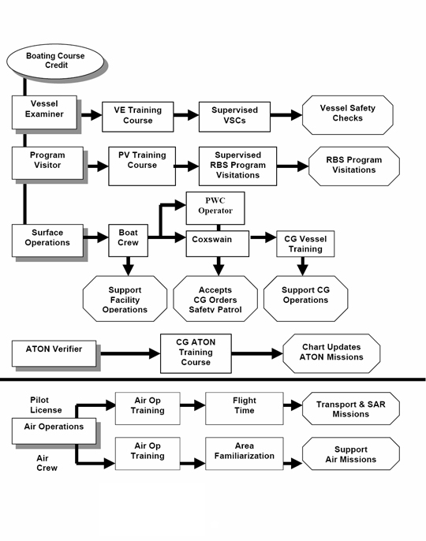QUALIFICATIONS TRAINING

Each of these qualifications require Boating Course Credit

Air Crew/ Observer

Each of these qualifications require Boating Course Credit

5 yrs service @ minimum 96 hrs yearly

Administrative Procedures Course or Flotilla Leadership Course

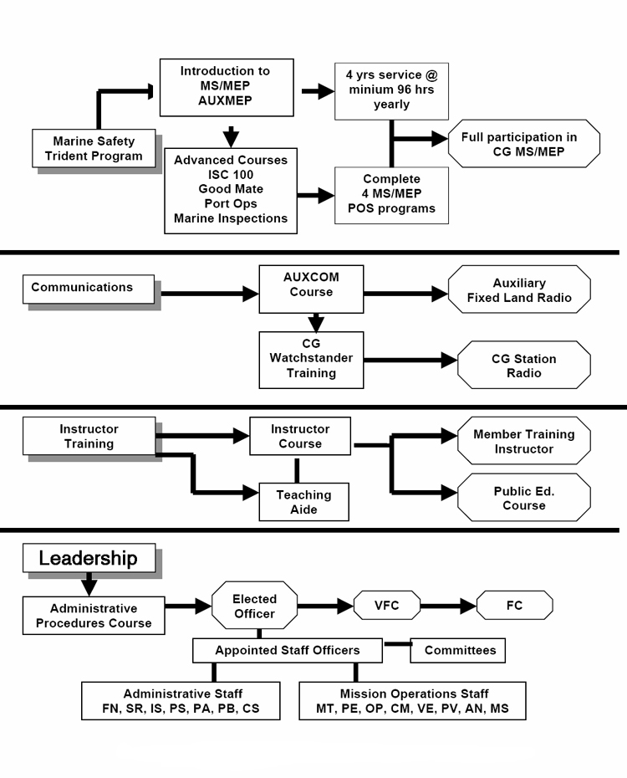Administrative Staff
MT, MA, FN, SR, HR, PA, PB, CS, IS
Mission Operations Staff PE, OP, CM, VE, PV, NS, MS

(Maintain periodic updates by MT/HR for planning.)
Name

(Use pencil for annual and update revisions)
QUALIFICATION / FACILITY | YEAR COMPLETED | GOAL FOR YEAR 20
BQ – Boating Safety Course
Instructor
Program Visitor
Vessel Examiner
ATON Verifier
Boat Crew
Coxswain
Trident CG Marine Safety/MEP
Air Crew/Observer
Pilot
AUX Operational Facility: Boat, PWC, Radio, Aircraft
USCG Watchstander
USCG Boat Crew
USCG Recruiter
Additional Training
AUX Advanced Coastal Navigation
AUX Seamanship
Auxiliary Search Coordination and Execution
AUX Patrol
AUX Weather
AUX Communication
AUX Operations
AUX Marine Environmental Protection
Administrative Procedures Course (APC)
Flotilla Leadership Course
AUX Leadership and Management (LAMS)
AUX Mid-Level Officer Course
AUX Senior Officer Course
CG Institute Course(s)
National “C” School Course(s)
LEADERSHIP
Staff Office:
Elected Office:
Other:

