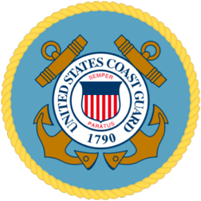

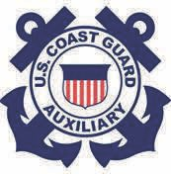Coast Guard Station
Wilmette Harbor

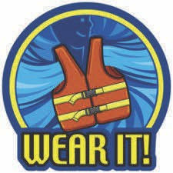
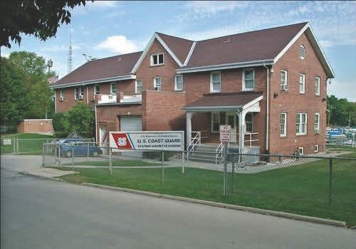

Come to the Coast Guard Station at Wilmette Harbor on
Saturday, May 22nd 10 AM - 4 PM
and help us celebrate the beginning of
National Safe Boating Week!

Come tour the station! Some of the other items to see and do will be
∗ See the Coast Guard and Coast Guard Auxiliary boats
∗ Get boater education and vessel exam information
∗ Learn about marine pollution and keeping the water clean
∗ See different types of life jackets and learn the importance of them
∗ Rescue 21—Learn what it’s about!

Coast Guard Station
Wilmette Harbor is
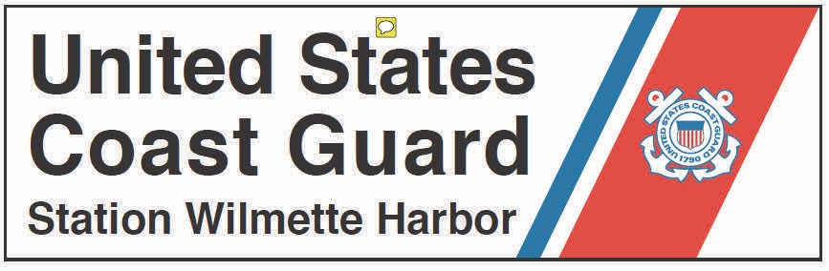located in Gillson Park, on Harbor Drive directly East of Sheridan Shore Yacht Club.

