UNITED STATES COAST GUARD AUXILIARY
REQUESTING AND HOSTING A WebEx Session
03.13.2015

The individual whose role is to serve as the WebEx host is requested to follow this procedure to setup a WebEx session.
- Navigate your web browser to: http://www.cgaux9wr.com/programs/mt/webex-form.php

- You will see the message, click the Login In link to proceed:

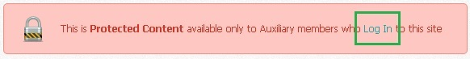

- Enter your numerical CGAUX Member ID and Password; then click Log In:

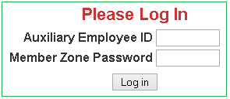

- Upon successful authentication you will be taken to your Member Information page. On this page click the "WebEx Conference Request Form" link:

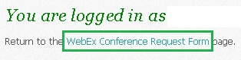

- You are required to enter the details of your WebEx session request. Those fields outlined in red are mandatory.
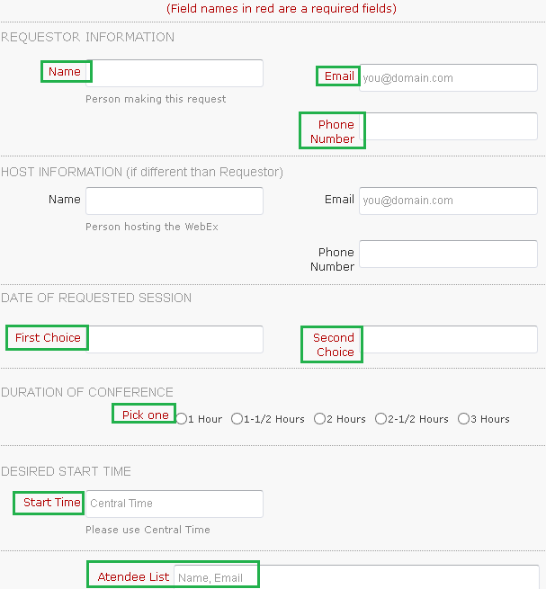
- When complete, click Submit.

- You will see a webpage summarizing your WebEx session request as noted in the example below:
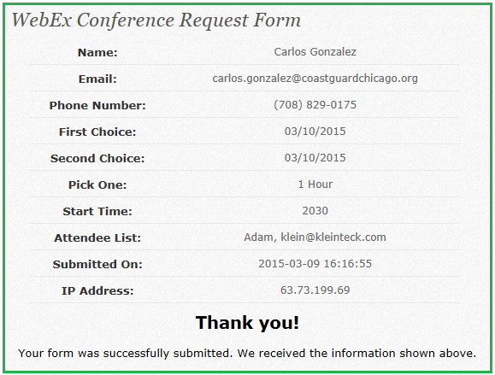

- All members will receive a WebEx meeting invite via email as noted in the example below.
  - Note: The Meeting number and Access code listed in the email will be UNIQUE to your WebEx session.
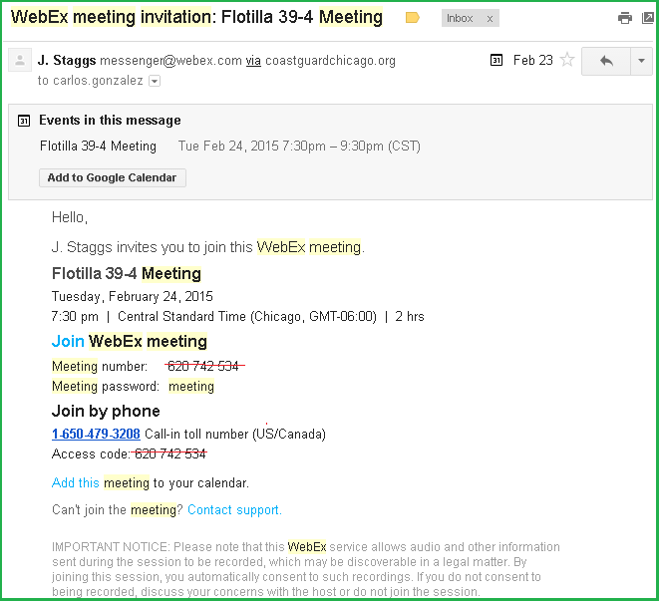
- The host should expect to receive an email from Amy Seeley division39.vdcdr@gmail.com, detailing the HOST USER NAME and PASSWORD. The HOST login credentials are NOT to be shared with the general membership.

  - The host is asked to contact Amy if the Host credentials are not received within a few days of having had submitted the WebEx session request.

  - The host is asked to send email to their WebEx session participants confirming they have received a WebEx meeting invitation email. If session participants state an email has not been received send email to Amy Seeley requesting a status update.

  - The host is asked to remind WebEx session participants to connect to the WebEx session about 15 minutes before the start of the meeting as it can take some time for the WebEx software to install for first time users.
STARTING THE WEBEX SESSION AS A HOST
- About 15 minutes before the start of the meeting the host is asked to navigate their web browser to:
http://aux095meet.webex.com/
- Enter the HOST username and password provided by Amy Seeley:

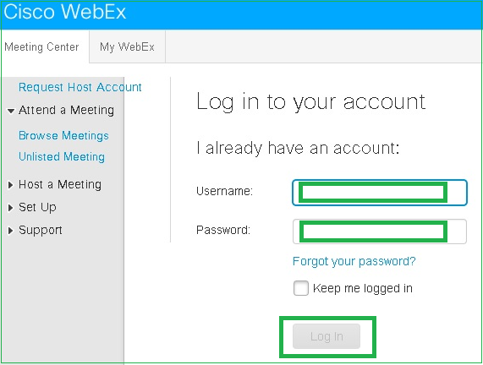

- Upon successful authentication the host is able to click the Enter Room button to begin the WebEx session:

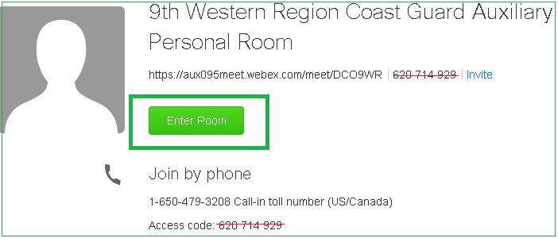

STARTING THE WEBEX SESSION AS A PARTICIPANT

- WebEx session participants are able to click the Join WebEx meeting link from their email invite to start the WebEx session.

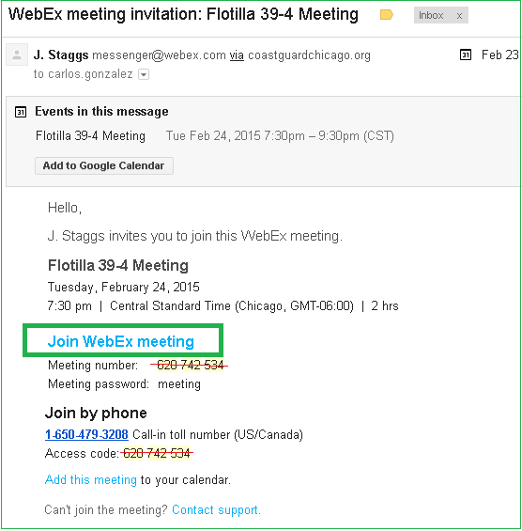

This document was created by: Carlos A Gonzalez, FSO-CS, 095-39-04, carlos.gonzalez@coastguardchicago.org

