Coast Guard Auxiliary 7029 Time Entry
11.30.2013

Coast Guard Auxiliary members are strongly encouraged to enter their time of service on an on-going basis. Time entry is the method by which the United States Government procures funds and resources for the use of the local Flotillas.
TIPS FOR SUCCESSFUL 7029 TIME ENTRY
i. Read this document in its entirety before attempting to enter your time into the web-based forms.
ii. Ensure you have all your questions answered by a time entry subject matter expert before you enter your time.
iii. Detail your time in a handy excel spreadsheet prior to entering your time.
iv. During the time-entry process, SAVE your time-entry sheet often, to help ensure you do not lose data entered resulting from web browser time-outs or loss of network connectivity.
v. Once you have SUBMITTED your time, ensure you review the corresponding time-entry email to verify the data you entered was successfully submitted. If by chance your data was not submitted you are able to start a new time-entry form for the remaining dates of your service.
vi. Within this procedure there is reference to time entry forms: 7030, 7038, 7039 and 7046. Generally speaking all time entry will be submitted within the 7029 form unless otherwise directed.

Login to your webforms.cgaux.org account

- Navigate your web browser to: http://webforms.cgaux.org

- In the upper left-hand corner enter your numerical Member ID and Password; then click the LOG IN button:

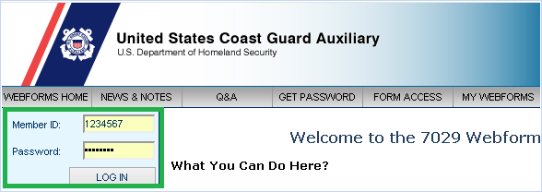

- Your name is located in the upper left-hand corner of the web browser. Click the 7029 Form Access link located directly below your name:
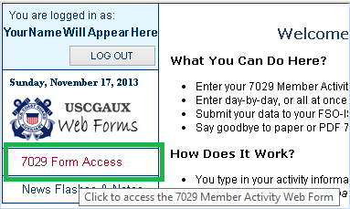
- Click the 7029 – Version 1.1 link which will appear directly below the prior 7029 Form Access link:
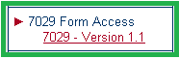

Starting the Time Entry Process:

- Click the NEW button to start your time entry:

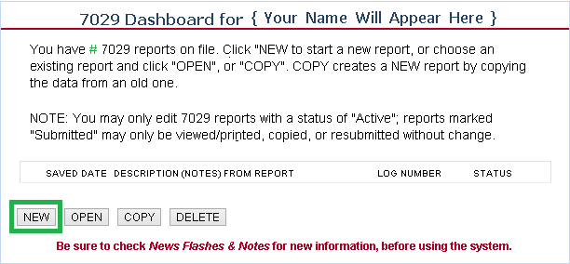

- You will be taken to the following screen:
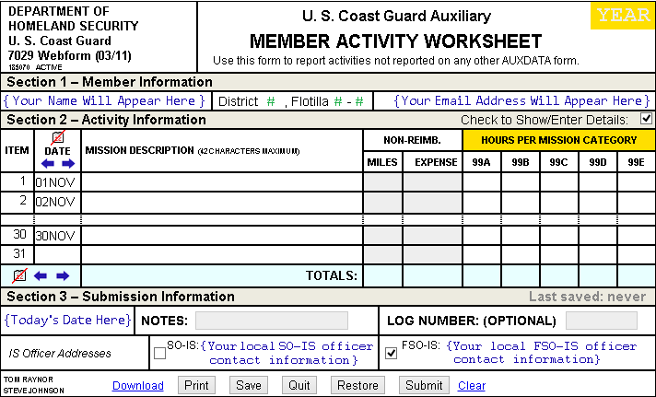

- FIND THE DATE OF THE SERVICE YOU PERFORMED: Click the right and left blue arrows located within the DATE box.
  - Click the right arrow to advance the monthly date range forward.
  - Click the left arrow to reverse the monthly date range.
  - Go to the month of the service you performed.
  - Scroll down the webpage to the day of your service.

- Define the MISSION DESCRIPTION: Click the Mission Description field next to the date of your service. Enter for your own reference, a 42 character maximum description, of the service you performed:
- Define the NON-REIMB. – MILES: Enter the number of UN-REIMBURSED miles you drove in your personal vehicle for your reported Auxiliary activity:
- Define the NON-REIMB. – EXPENSE: Enter the amount of any UN-REIMBURSED expense required for your reported Auxiliary activity, such as tolls, parking, meals and lodging:
- Define the HOURS PER MISSION CATEGORY – 99A: AUXILIARY STAFF – Report all time spent by elected and appointed staff performing National, District, Division and Flotilla position duties. This includes all time spent for preparation and travel for these duties:
- Define the HOURS PER MISSION CATEGORY – 99B: Recreational Boating Safety – Report all time spent in RBS Support that is not otherwise reported on a 7030, 7038, 7039 or 7046 form. This includes all time for preparation and travel in support of missions reported on 7030 and 7038:
- Define the HOURS PER MISSION CATEGORY – 99C: Mission Support – Report all time spent in Mission Support that is not otherwise reported on a 7030 or 7038. This includes all time for preparation and travel in support of Marine Safety, Marine Environment Protection, Commercial Fishing Vessel, Uninspected Passenger Vessels and Uninspected Towing Vessels:

- Define the HOURS PER MISSION CATEGORY – 99D: Member Training – Report all time spent in Training Support that is not otherwise reported on a 7030 or 7039. Any hours spent as a Trainee, other than attending a workshop, should be reported here. This includes all time for preparation, study, homework and travel regardless of the level of training:
- Define the HOURS PER MISSION CATEGORY – 99E: OTHER – Report all time spent for Auxiliary and CG Support missions not otherwise reported on any other form or any other Mission Code above. Include all time working on committees or attending meetings (if you are not an elected or staff officer). This includes all time for preparation and travel:
- Once time entry is complete scroll to the bottom of the webpage and click the SAVE button – SAVE your time entry often :
Note: It is possible you may be automatically logged off the website upon clicking the SAVE button. This is due to the automatic security time-out / log-off feature resulting from an extended period of inactivity.
- Once your data is SAVED the webpage will stay within the same time-entry page. Scroll back down to the options as noted below and click the SUBMIT button.
- The following webpage will appear summarizing your entered time:
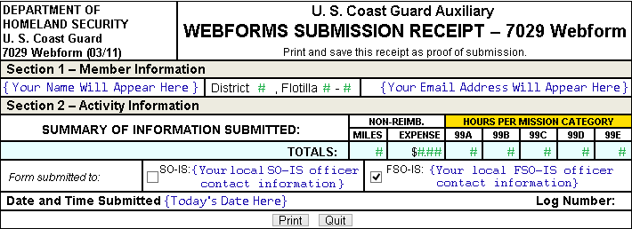
- You will receive an email as noted below summarizing the time you entered:
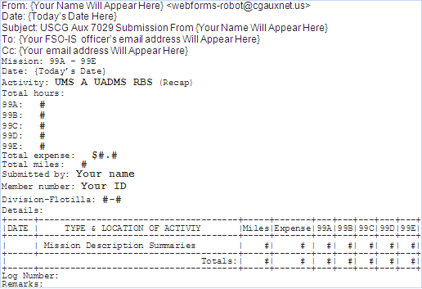
Pause the Time Entry Process:
- If at any time you wish to pause your time entry session, ensure you have SAVED your data and then click the QUIT button:
- You will be taken back to the 7029 Dashboard. From the Dashboard you will have the option to click time entry logs with a STATUS of ACTIVE and then click the OPEN button to resume your time entry session:

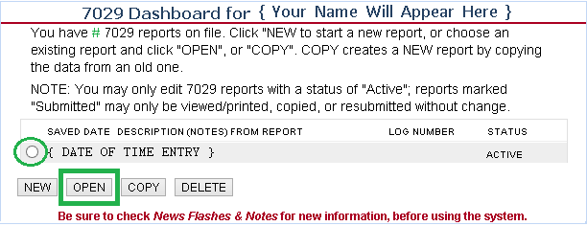

This document was created by: Carlos A Gonzalez, FSO-CS, 095-39-04, carlos.gonzalez@coastguardchicago.org

