AuxDirectory/AuxOfficer: Search Auxiliary Member Contacts / Update Personal Information
11.30.2013

The following instructions will help you update your contact information (new email address information) on the Coast Guard Auxiliary’s AuxDirectory/AuxOfficer website:

- Navigate your web-browser to: http://www.coastguardchicago.com. You will be directed to the Flotilla 39-4 District Web Site.

- In the middle left-hand side of the screen you will see the MEMBER ZONE login prompts. Enter your numerical Member ID and Password; then click the LOG IN button:

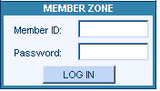

- Go to the AUX MEMBERS menu at the top of the screen and select the AUXILIARY DIRECTORY option:

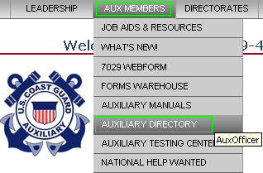

- You will be taken to the AuxDirectory/AuxOfficer URL at: https://auxofficer.cgaux.org/auxoff/

- Login once again using your numerical Member ID and Password and click the “Log in to Auxiliary Directory” button:
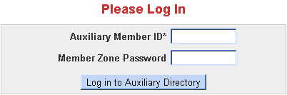
- Locate your directory entry:

  - Enter your Last Name within the field entitled, “Enter Last Name, Member #, Email or Phone #”.
  - Enter your Unit number within the “Unit (e.g. 114-12-04)” field: 095-39-04
  - Click the SEARCH button:

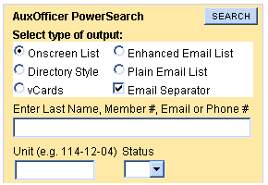

- Click on your name within the Power Search Results window.
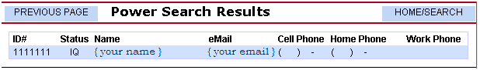
- Scroll down below and click the “Correct the Above Information (7028 Webform)” button:

- You will be taken to the “Webform 7028 - Change of Member Information” website. Update your email address and any other relevant contact information.

- Click the “Submit Changes” button to update you contact information:

This document was created by: Carlos A Gonzalez, FSO-CS, 095-39-04, carlos.gonzalez@coastguardchicago.org

