Configure your @coastguardchicago.org email address to auto-forward
11.30.2013

The Flotilla 39-04 Leadership Team encourages its members to use their @coastguardchicago.org email address for Flotilla related matters. The following instructions were created in an effort to help you with the transition to using your @coastguardchicago.org email address on a regular basis. Please note these configuration settings are optional.
Login to your @coastguardchicago.org account
- Important: Navigate your web browser to: http://www.gmail.com

- Important: Type your entire Username@coastguardchicago.org email address into the Username field and Password and click the “Sign in” button:
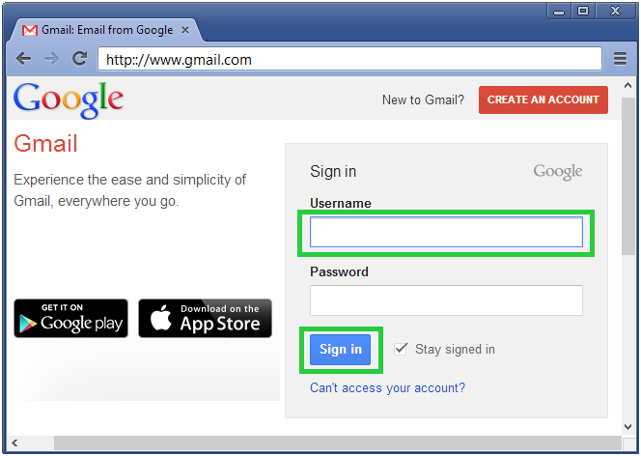
- Important: Upon successful login you will see the Coast Guard Auxiliary flag and your Coast Guard Auxiliary email address as noted below:
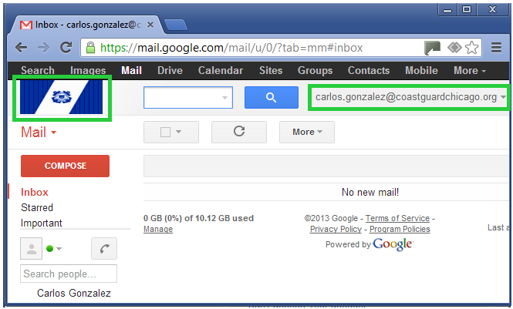

OPTIONAL: Forward Email from your @coastguardchicago.org email address to a secondary email address.

You have the option to send and receive emails from your @coastguardchicago.org address. Follow the following instructions to forward email received into your @coastguardchiacgo.org address to a secondary email address.
- Click the icon and select the “Settings” menu option:
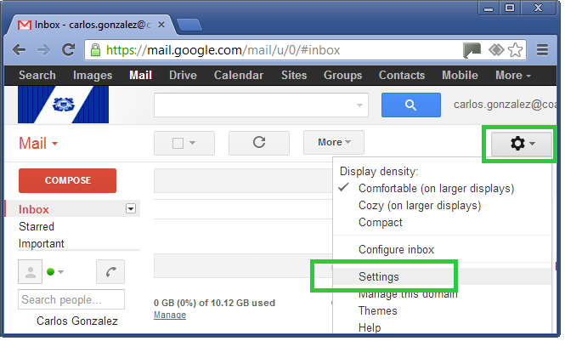
- Click the “Forwarding and POP/IMAP” tab followed by the “Add a forwarding address” button:
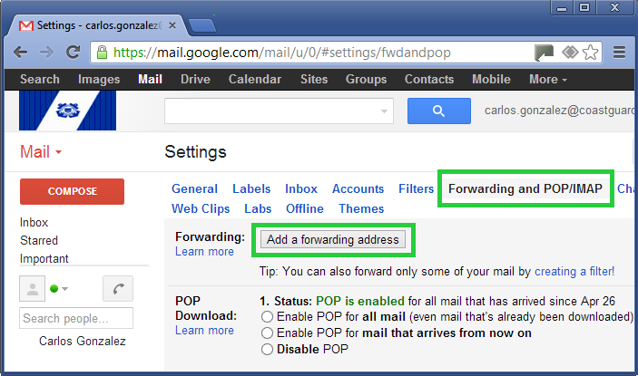
- Enter your preferred secondary email address into the text box as noted below and click the “Next” button:
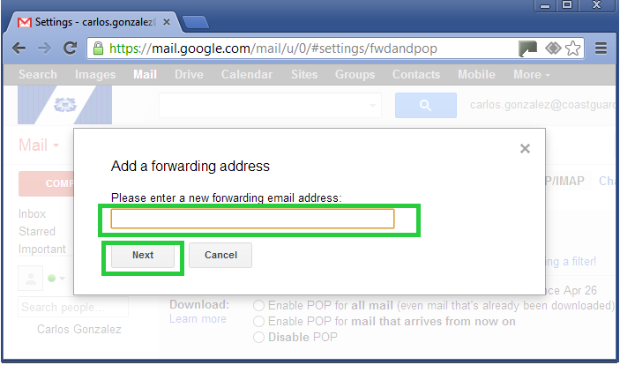
- In this example I will establish a secondary forward from my carlos.gonzalez@coastguardchicago.org address to my “secondary” email address: carlosatnelson@gmail.com:
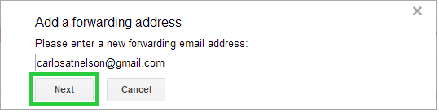

- Proceed with the confirmation:
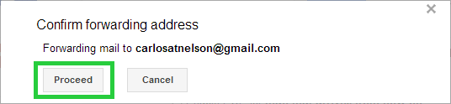
- Acknowledge the confirmation code message:
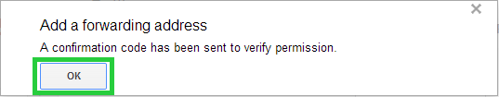
- Go to your “secondary” email account and click your unique link which will be found in the same area as the link outlined below:
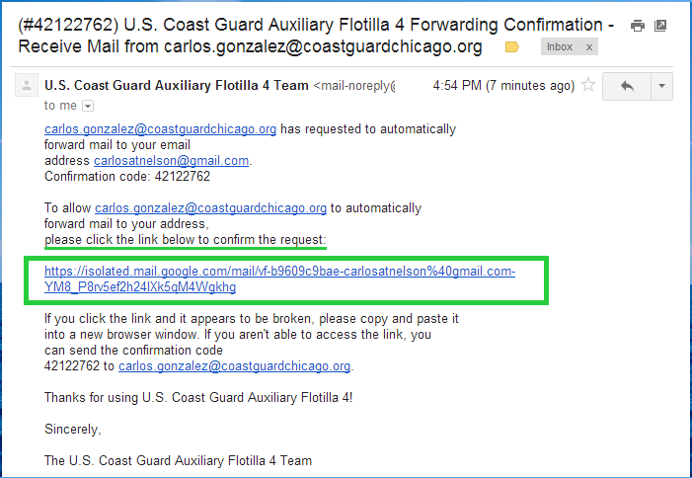
- You will be taken to a “Confirmation Success!” message:
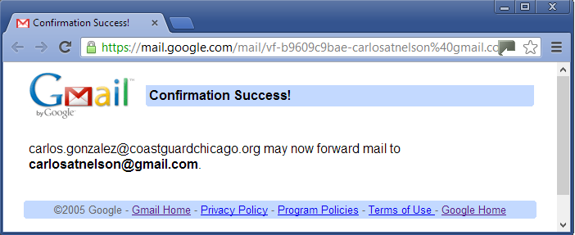

Enable the Forwarding to your secondary email address:
- Go back to the icon and select the “Settings” menu option. Select the “Forwarding and POP/IMAP” tab once again. Under the Forwarding option the “Disable forwarding” selection will be enabled.

  - Click the option: “Forward a copy of incoming mail to “secondary email address” and select either one of the four choices in the image below:
    - Keep U.S. Coast Guard Auxiliary Flotilla 4 Mail’s copy in the Inbox – Highly Recommended
    - Mark U.S. Coast Guard Auxiliary Flotilla 4 Mail’s copy as read
    - Archive U.S. Coast Guard Auxiliary Flotilla 4 Mail’s copy
    - Delete U.S. Coast Guard Auxiliary Flotilla 4 Mail’s copy

  - Click the Save Changes button.
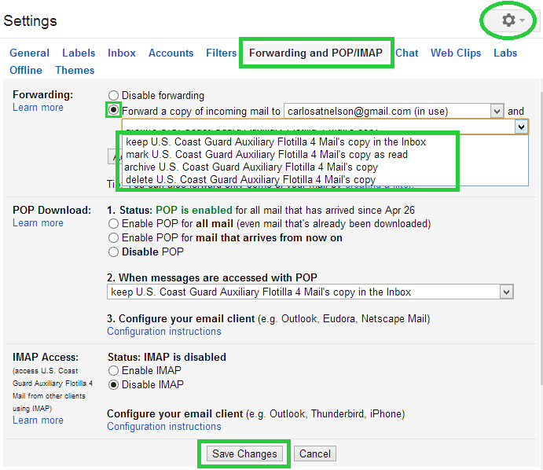
This document was created by: Carlos A Gonzalez, FSO-CS, 095-39-04, carlos.gonzalez@coastguardchicago.org

