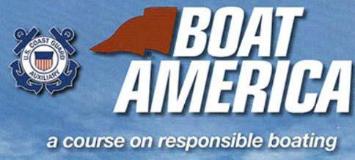

* Trailering your boat or personal watercraft
* Rules of Navigation - who has the right of way?
* Equipment - what you should carry on the water
* Personal watercraft
* Handling boating emergencies
* Common Sense Boating ….and more!

Take a Class to learn about:

***Courses held from 8 AM to 5 PM at:***

**Eagle Mountain Marina**

[**https://eaglemountainlakemarinas.com/**](http://www.scottslandingmarina.com/)

**6500 Wells Burnett Rd**

**Fort Worth, TX 76135**

**Saturday, May 18**

<https://tpwd.elementlms.com/course/boater-education-classroom-course-2356/>

# Saturday, April 27

# <https://tpwd.elementlms.com/course/boater-education-classroom-course-2355/>

**Saturday, March 30**

<https://tpwd.elementlms.com/course/boater-education-classroom-course-2351/>

# Saturday, June 29

# <https://tpwd.elementlms.com/course/boater-education-classroom-course-2354/>

# Saturday, August 31

# <https://tpwd.elementlms.com/course/boater-education-classroom-course-2352/>

# Saturday, July 27

# <https://tpwd.elementlms.com/course/boater-education-classroom-course-2353/>

**GUARANTEE YOUR SPOT – PRE-REGISTRATION IS RECOMMENDED 1 WEEK PRIOR TO CLASS DATE**

Contact Linsey Zimmermann | [Linseyuscga@gmail.com](mailto:Linseyuscga@gmail.com)

Tuition-$50 – **Cash or Check Only**

Includes TPWD Certification + USCGAux Course Completion Certificate