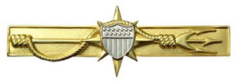
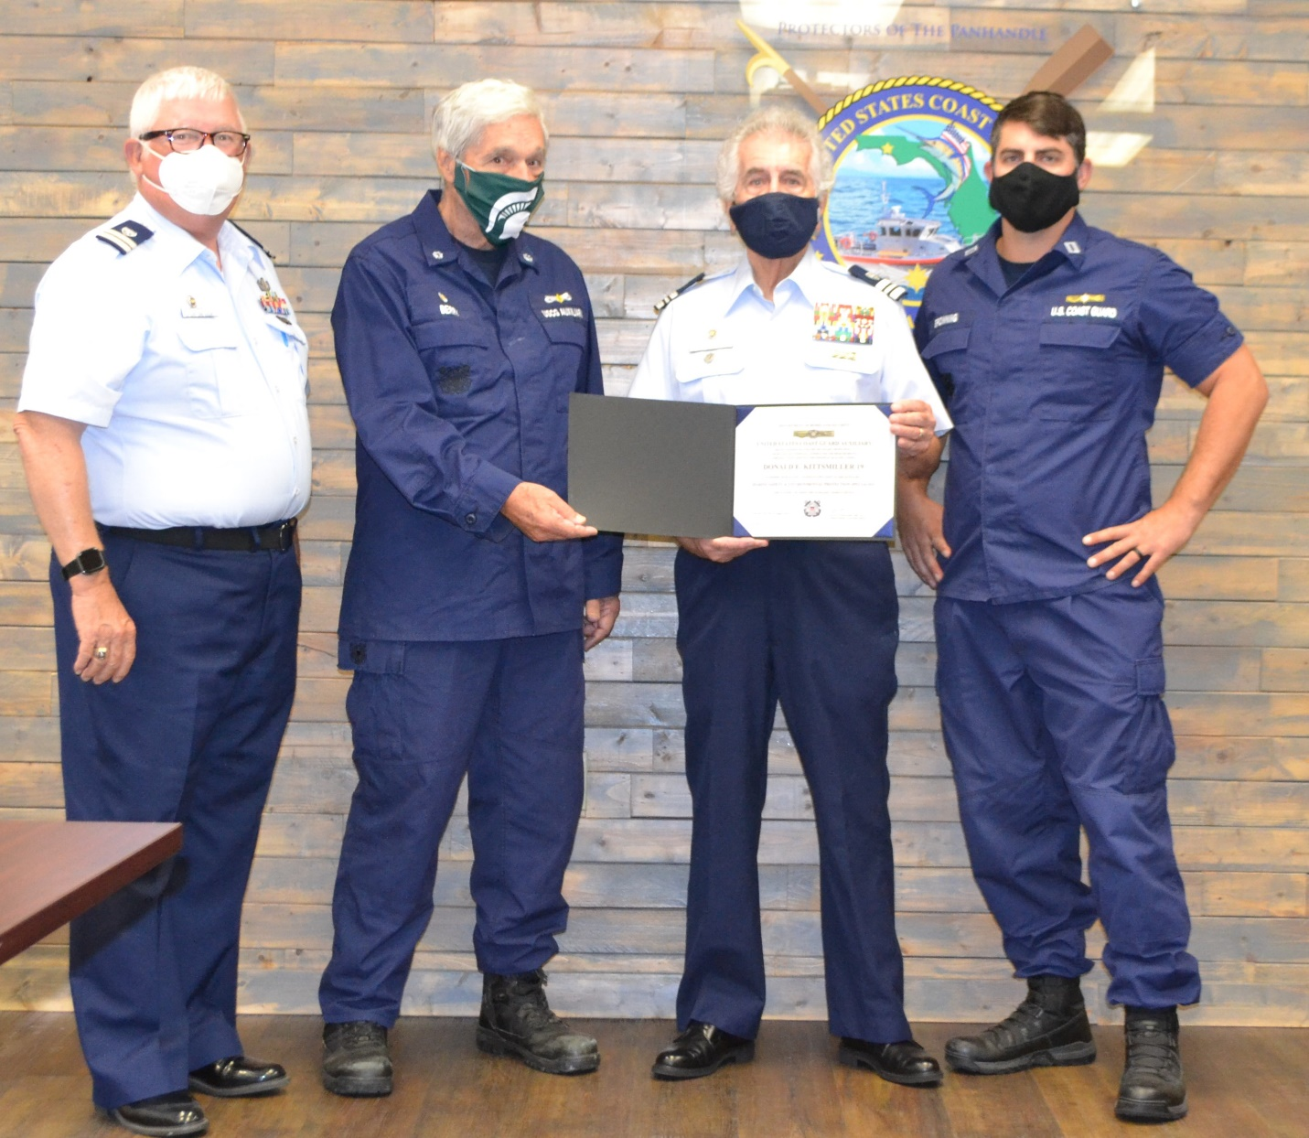
Pictured are Auxiliary Members Mike Fitzgerald (F19 FC), Daniel Berry (Division Commander), Donald Kittsmiller, and Lt. Steve Browning (Supervisor, Panama City Marine Safety Detachment)
Photo by MST1 Brendan Blackwell, USCG MSD PC

