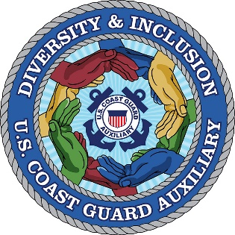

WHAT IS ILEAD?
ILEAD is an all-Coast Guard Initiative, which was initiated by the Commandant. It stands for Inclusive Leadership, Excellence, and Diversity. It provides our members with the opportunity to share concerns and best practices. The Auxiliary has a seat at the table.
WHY IS IT IMPORTANT?
Diversity, Inclusion, Leadership, and Excellence are priorities of the U.S. Coast Guard and our leadership at the highest levels.
WHAT IS AN LDAC?
LDAC stands for Leadership Diversity Advisory Council. It is the "local" unit. Its goal is to create and maintain a positive environment where everyone is encouraged to use their unique talents and skills.
HOW IS MY DISTRICT INVOLVED?
Auxiliary LDACs at the District level invite input from members, share with leadership and pass trends up to Auxiliary leadership and the National ILEAD Council for review and possible action. (Districts may take action to solve problems and implement best practices.)
WHAT IS THE BENEFIT TO MY DISTRICT, DIVISION, FLOTILLA?
Improved Recruiting; Member Retention; Re-engagement of members thinking of leaving, as well as Improved efficiency and morale.
These are not pie in the sky goals. They are statistically proven.

