The Binnacle

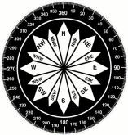

*“Providing members of the Jacksonville Beach Flotilla of the U.S. Coast Guard Auxiliary with the way forward”*

**Exploring the depths of Marine Paleobiology: Unraveling the Mysteries of Ancient Oceans.**

**Daniel R. Tardona**

Marine paleobiology is a multidisciplinary field that combines principles of paleontology, biology, climatology and geology to unravel the mysteries of life and conditions in ancient oceans. The study of marine fossils provides valuable insights into the evolution of marine life, paleoecology, and the changing dynamics of Earth’s oceans through geological time. Just as understanding present earth conditions is a key to the past, past history can provide clues to earth’s future.

Marine paleobiology focuses on the examination of fossilized remains of marine organisms to reconstruct the evolutionary history and ecological interactions within ancient ocean ecosystems. The field is essential for deciphering the intricacies of life in marine environments, ranging from microscopic plankton to massive marine reptiles. Fossilized remains offer glimpses into conditions in the distant past revealing the diversity of species, their adaptations, extinctions and the ecological roles ancient sea life played. Comparing ancient and modern marine life enables scientists to trace the development of species through time and the factors that influences their evolution, survival and extinction. Through such study scientists can reconstruct paleoenvironments, track evolutionary trends, and understand the response of marine life to environmental changes over geological time scales.

The analysis of marine fossils contributes to our understanding of past climate changes and their effects on marine ecosystems. For example, the study of foraminifer provides insights into ancient sea surface temperatures and oceanic circulation patterns. Foraminifera (among scientists they are called “forams” for short), are single-celled organisms that have a shell. They have been around for the last 540 million years. They range in size from about 100 micrometers to 20 centimeters fully grown. These tiny animals have been used to map past distributions of the tropics, locate ancient shorelines, and track global ocean temperature changes during the ice ages. The chemistry of the shell is useful because it reflects the chemistry of the water in which it grew. Fossil shells collected in deep-sea cores from around the world have been used to map past surface and bottom water temperatures. These data help scientists to understand how climate and ocean currents have changed in the past and may change in the future.

Today forams number in the neighborhood of 4,000 species, 40 of which are planktonic (float in water), the rest live on or in rocks, plants, and sediments at the bottom of the sea. Foraminifera are found in all marine environments, from the intertidal to the deepest ocean trenches, and from the tropics to the poles,

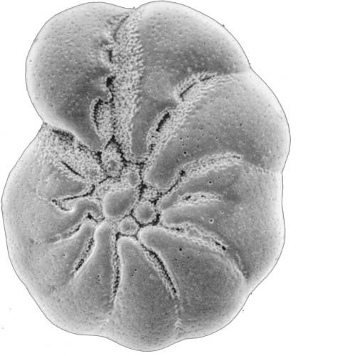

*Elphidium liodense* (Cushman)

From the Quaternary of the Dovey Estuary, Wales.

Courtesy of the British Geological Survey

Understanding the historical dynamics of marine life aids in predicting how modern marine ecosystems may respond to ongoing environmental changes. The study of ancient ocean conditions hold clues to past climate variations, offering insights into the drivers of long-term climate change. Geochemical analyses of sediment cores and fossilized marine organisms provide information about temperature, ocean acidity, and carbon dioxide levels through time. Marine paleobiology contributes valuable data for conservation efforts and the sustainable management of marine resources.

As technology advances, new methods and approaches in marine paleobiology continue to emerge. High-resolution imaging techniques, molecular analysis, and advanced modeling tools will likely provide deeper insights into the complexities of ancient marine life and ocean conditions.

Understanding the paleobiological and geological history of oceans is paramount to deciphering the present state of marine environments. Geological records, such as sedimentary layers and rock formations, serve as archives documenting past ocean conditions. By analyzing these records, scientists can identify tectonic processes and comprehend sea-level fluctuations. Tectonic processes refer to the [dynamics](https://www.merriam-webster.com/dictionary/dynamics) of [Earth](https://www.britannica.com/place/Earth)’s outer shell and the evolution of Earth’s surface and reconstructing its past continents and oceans. Such insights are crucial for predicting future changes and understanding the impacts of human activities on modern oceans.

**References**

Allmon, W. D. (2014). The importance of paleontology in defining and solving real-world

problems. *Palaios*, 29(10), 492-498.

Briggs, D.E. and Crowther, P. R (Eds,). (2001). *Paleobiology II Wiley-Blackwell*

Dietl, G. P. (2016). Brave new world of conservation paleobiology. *Frontiers in ecology*

*and evolution*. 4, 21.

Stanley, S. M. and Luczaj, J. Eds. (2014). *Earth System History*. W. H. Freeman and Company