The Binnacle

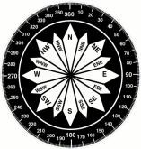

*“Providing members of the Jacksonville Beach Flotilla of the U.S. Coast Guard Auxiliary with the way forward”*

**USCG Auxiliary Flotilla 14-4 Jacksonville Beach Meeting**

WHEN: Tuesday, 03SEP24@ 1900

WHERE: Internet and in person at Sea School   
  
Topic: Flotilla 14-4 Meeting  
Time: Every month on the 1st Tuesday, 1900 (7:00 pm)

Flotilla 14-4 is inviting you to a scheduled Zoom meeting. Topic: Flotilla 14-4's Zoom Meeting

Time: September 3, 2024, 7:00 PM Eastern Time (US and Canada)

To join via Zoom: simply open Zoom in your browser, click on “Join”, and enter the Meeting ID, shown below.

https://us02web.zoom.us/j/87135925618

Meeting ID: 871 3592 5618

**FLOTILLA MEETING:** Tuesday, 03SEP24, 1900

COMMANDER’S CORNER

D-Train will be held at the Florida Hotel and Conference Center, Orlando, from 18SEP – 22SEP24. Provides tremendous opportunities for members looking to expand their auxiliary footprint. Chad Shores and Alexander Adak attending on behalf of 14-4

Division elections at October Meeting. Submit letter of intent to Sean Flynn NLT 15SEP24, if you intend to run for Division Commander or the Vice Division Commander.

**Flotilla elections at November Meeting. We will need candidates for both FC and VFC. Submit a letter of intent to Bob Cook as soon as possible, but before 30SEP24.**

Change of Watch: Mavi reserved for 03DEC24, details to follow.

EVENT SPEAKER

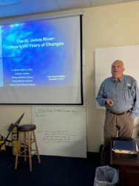Quinton White, Jr. Ph.D. Dr White is Executive Director, Marine Science Research Institute and Professor of Biology and Marine Science at Jacksonville University. White joined the faculty at Jacksonville University in 1976, having completed his Ph.D. at the University of South Carolina at the Baruch Institute for Marine Biology and Coastal Research. Dr. White has written numerous research and technical papers or reports and received grants and contracts to support marine research at JU. Currently he is conducting research on the history of human impact on the Florida environment and especially on the St. Johns River with a focus on manatees and water quality issues. Dr. White has been active in the Jacksonville community. He writes a monthly column in the Florida Times-Union called “River Life” focusing on river related issues. He serves as a consultant to the City of Jacksonville’s Waterways Commission. He was active in establishing the shark tracking organization OCEARCH at JU as an exciting new program now affiliated with the MSRI.

**Photo by FSO-PB Erlinda Lopez Sept 3, 2024**

AWARDS

AWARDS

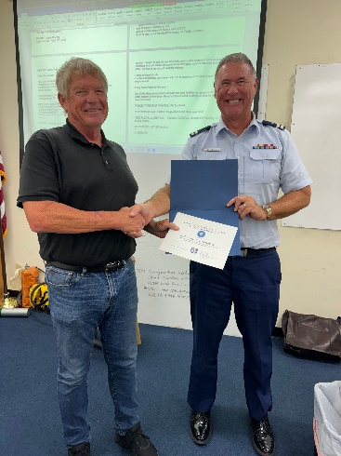

United States Coast Guard Auxiliary Certificate of Appreciation. FSO-HR Kevin Holbrooks December 31, 2023

**Photo by FSO-PB Erlinda Lopez, Sept 3, 2024**

UPCOMING

NEXT FLOTILLA MEETING: Tuesday, 01OCT24, Membership Meeting, on-line or at Sea School.