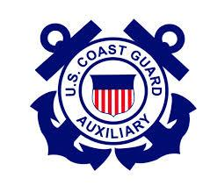

Flotilla 96, Wiggins Pass Presents



**Monday, March 24, 2025**

**6:00 – 8:00 PM**

**Flotilla 96 Station  
13531 Vanderbilt Drive**

***Cocohatchee River Park***

**Naples, Florida**

**Local Waters**

**$45 Per Person**

**Register by calling:**

**(239) 594 - 8009**

**

Our Local Waters Knowledge course has been prepared by the U.S. Coast Guard Auxiliary Flotilla 96 Wiggins Pass. It is designed to provide information on how to safely navigate the channels and waterways inside the Southwest coast of Florida along the Gulf of Mexico. Our course includes up to date information on area waterway conditions, video navigational instruction, marine-related topics, discussion, and Q&A.

Videography and course content features Wiggins Pass to Matanzas Pass, Little Hickory and Estero Bay plus the estuarial waters of Vanderbilt Lagoon, Water Turkey Bay, and the Cocohatchee and Imperial Rivers.

***Navigating Local Channels and Waterways***

**Knowledge**

**The United States Coast Guard Auxiliary is the uniformed, all-volunteer, non-law enforcement division of the  
 United States Coast Guard. Boating safety is our business. For more information, please visit www.cgaux.org.**