USCG Auxiliary Sustained Service Awards
Flotilla 54-23-07 Herring Bay
Presented 15AUG2022
FC Brian Shrift presents Joe DiStefano with the Sustained Service Award. Joe also received his Instructor Certificate.
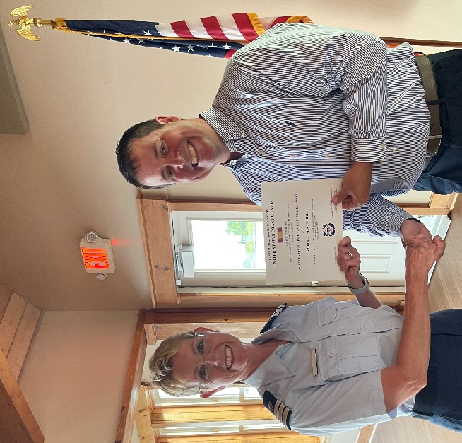
FC Brian Shrift presents Robin Ainsworth with the Sustained Service Award.

