Prospective Member Guide
BE PART OF THE ACTION!
"TEAM COAST GUARD"

United States Coast Guard Auxiliary
5th District, Southern Region
Division 20, Flotilla 05
New Bern, NC 28560

As of: 1 July 2012
Table of Contents

Flotilla 20-05 Meeting Times and Location ...................................... 4
Requirements for Membership ...................................................... 5
New Membership and Indoctrination Forms..................................... 6
New Member Course Study Materials ............................................. 7
Other Resources ......................................................................... 7
Prospective Member Orientation.................................................... 8
What is the Auxiliary?.................................................................. 8
What Members Can Expect from the Auxiliary ................................ 8
What the Auxiliary Expects from Members...................................... 8
Important of Professional Conduct in all Activities............................ 8
Every Member is Expected to Participate in Some Program .............. 9
Organization of the Flotilla ........................................................... 9

Dear Prospective USCG Auxiliarist Member;

My name is Ed Daily, and I am the Auxiliary Personnel Services Officer for Flotilla
20-05, District 5, Southern Region. Thank you for your interest in joining the United
States Coast Guard Auxiliary (USCG AUX), the largest volunteer marine safety organization in the world. It is our hope that this Guide, will help you become familiar with who we are and what we do. Please take the time to read this information and consider what the “commitment of membership” means to you. If you feel that the Auxiliary is an organization that you want to be a part of, we will assist you in becoming an active and productive member.
Please understand however, we are NOT a Yacht Club. We are a service organization composed of volunteers with an emphasis on activities that support the many and varied U.S. Coast Guard missions in which we participate. Keep in mind that although we want you to become a dedicated member, we understand that you will need to juggle your personal commitments to family, friends, home, work, and community; therefore, we allow you to proceed at your own pace and will work with you according to your availability.
The packet I provided you has all the information, forms and study materials you will need to prepare your application and take the New Member examination; if you have any questions or need assistance, please contact me. At the end of this document you will find a list of USCG and USCG Auxiliary web sites that you will find useful in providing information you will need when you become a member of the Auxiliary.
The basic steps for membership are as follows:
1. Learn about the Auxiliary, what we offer, and what you want to contribute
2. Complete the new member application, forms, and indoctrination process (including a personal security investigation, i.e., background check).
3. Costs associated with Auxiliary membership: Member’s dues are $35 annually. Uniforms will be approximately $150 to $250. All costs associated with your work with the Auxiliary are tax deductable.
4. Study, take, and pass the Auxiliary New Member Course/Exam (via online, self-study, or in an instructor-led class).
5. Provide proof of having completed a boating safety course or attend, study, and pass a safety boating class/exam (online or via an instructor-led class).
If you have any questions whatsoever, please feel free to contact me at the numbers/email
shown below. Thank you again for considering membership in the USCG Auxiliary. I look forward to hearing from you again.
Semper Paratus,
Ed Daily
Mr. Ed Daily
Personnel Services Flotilla Staff Officer (FSO-HR)
5th District, Southern Region (5SR)
Division 20, Flotilla 05 (20-05), New Bern, NC
Home: 252-637-4732; Cell: 703-408-1432
Email: dailyep@aol.com
Flotilla 20-05 Meeting Times and Location

Flotilla 20-05 meetings are every 2nd Wednesday of the month. We meet at 7:00 pm
(19:00 military time).

Our flotilla meets at the Fairfield Harbour Library Building; see map below.

When you see the two entrances (one on the right and one on the left), make a left to the left-side Guard Shack(you will see a BB&T ATM Kiosk); just before the Gate you will make a right turn into the parking lot. We meet in the 2d building on the left. If you get lost, give me a call on my cell, which is 703-408-1432;I am usually there by 6:30 PM.

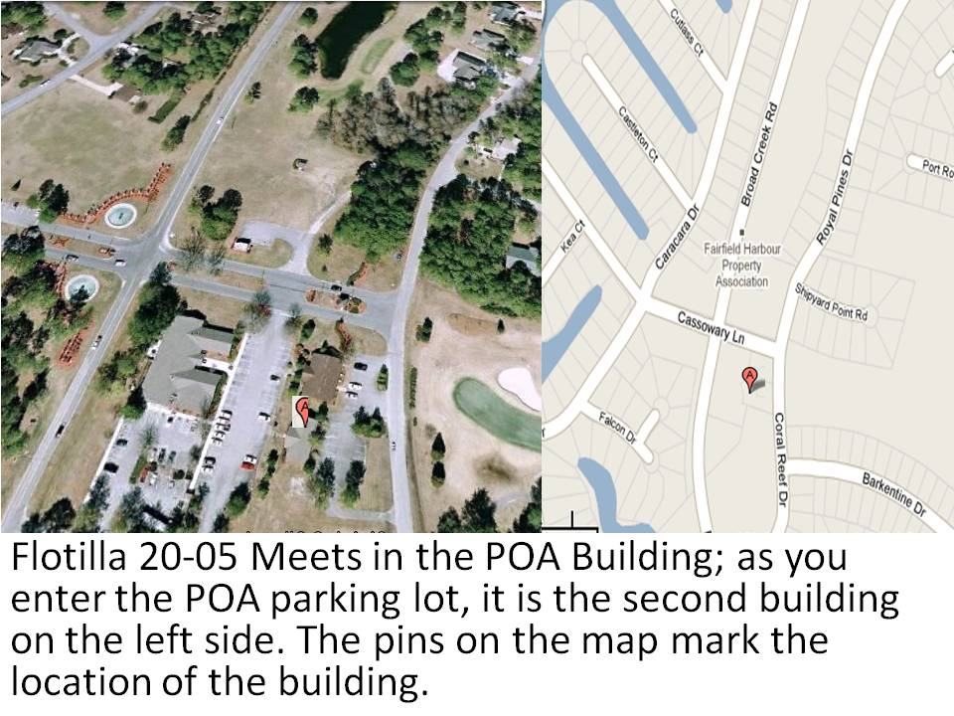
Requirements for Membership
There are two basic requirements for membership; (1) You must be a US citizen, and (2) you must be at least 17 years old. In addition to meeting the basic requirements for membership, there are other steps that you will need to complete on your way to becoming a full and active member.

First, learn what you can about the Auxiliary.
- Decide how you want to become involved
(http://www.uscg.mil/hq/cg3/cg3pcx/missions/), what activities are of
interest to you, and how and what you would like to contribute.
- Check out the visitors and members pages at
http://cgaux.org/about.php and visit
http://uscg.mil/hq/cg3/cg3pcx/publications/comdtinst/default.asp
- Check out the USCG Auxiliary History page at
http://www.uscg.mil/hq/cg3/cg3pcx/administration/aux-history.asp

Second, you must pass an entrance exam (not difficult) that covers the basics of the Auxiliary and how we function as an organization.

Three sources to prepare for the exam include: Note that you can either use the New Member CD provided in your packet or go online to the sites listed below.
- New Member Study Guide: http://hdept.cgaux.org/ . Scroll down the page to the section titled ‘Resource Toolkit” and you will find the Study Guide in the left column.
- New Member Reference Guide: http://hdept.cgaux.org/. Scroll down the page to the section titled ‘Resource Toolkit” and you will find the Study Guide in the right column.
- Auxiliary Manual
http://uscg.mil/hq/cg3/cg3pcx/publications/comdtinst/default.asp

Third, complete the Enrollment Application. Go to the PDF Forms site (http://forms.cgaux.org/forms.php) and scroll down to the 7001-Enrollment Application form and click on the Adobe Acrobat symbol on the right side of the screen.

Finally, you will need to pass a background investigation. All members of the Auxiliary must undergo a Personal Security Investigation (PSI). Your enrollment application is an agreement to undergo a Personal Security Investigation. However, the agreement to undergo the PSI is NOT a guarantee of membership. An unfavorable PSI determination may result in your disenrollment despite any training, duties, and activities you may have already performed, or any investments of time, effort, and resources you may have expended while awaiting your PSI determination. Use the links on the next three pages to access the documentation, forms, and materials that will help you prepare for membership in the USCG Auxiliary.

New Membership and Indoctrination Forms1

Item Comments

Basic Requirement 1: At least 17 years of  Age | Be prepared to show your Driver’s License as an ID that will verify your age.
Basic Requirement 2: US Citizen | Show proof of citizenship (e.g., birth  certificate or passport). Make copy to submit with your application.
New Member Enrollment Application  (7001)  http://forms.cgaux.org/forms.php | Fill-out all pages according to specific instructions and guidance provided by the FSO-HR.
New Member Interview | FSO-HR (Personnel Services) will assist you with section on the Application Form
FD-258 Fingerprint Cards  Your packet contains two USCG Fingerprint Cards | Go to the County Court House, Sheriff’s Department and ask for Dave Dodge; he is available on Tuesday and Thursday to take your fingerprints (there is no charge if he does them)
Auxiliary Enrollment ID Card Form  (the FSO-HR will email you the form) | You will not need to fill out the ID Card Form until you have been approved for membership based on a personal security screen.
New Member Examination and Exam Sheet | Study the materials provided in the packet and take the exam. Follow the instructions for filling out the examination score sheet. When you have completed the exam call the FSO-HR; he/she will grade the exam.
Boating Safety Course  http://www.cgaux.org/boatinged/  Also, see the next page for more options. | Take an approved boating class (online or in a classroom). Make a copy of the class certificate or boating card.
Flotilla Roster | While not a classified document, since it does contain personal information do not share this document with non-Auxiliary members

New Member Course Study Materials

Name | Web Address
America’s Boating Course | http://www.americasboatingcourse.com/
Auxiliary Boating Education | http://www.cgaux.org/boatinged/
Boating Safety Courses | http://www.uscgboating.org

Other Resources
There are many resources available to guide the Auxiliarist. Below are just a few to get you started. Additionally, you will be provided with a New Member Information and Orientation Guidebook once your application has been approved and you are placed in “Approval Pending” status (AP); you will receive a letter from the USCG Director of Auxiliary informing you of initial acceptance.
Name | Web Address
Auxiliary Members Web Site | http://www.cgaux.org/
USCG Auxiliary Training Department | http://www.cgaux.org/training/ (links to E-Learning, C-Schools, AUXOP, Leadership Courses, Value Training and under ‘Other Useful Links’ you will find links to ICS Courses, Guidebook for New Staff Officers, and “Knot Know How”)
5th District Web Site | http://a054.uscgaux.info/
Division 20 Web Site | http://a05420.uscgaux.info/  http://a05420.uscgaux.info/links.htm (Div 20 Links to other sites: Customs, Uniforms, AUX Manuals, Charts and waterways information)
New Member Uniform Presentation | http://hdept.cgaux.org/index.htm scroll down the page until you come to the section titled Resource Toolkit and look for Uniform Presentation
Uniform Procurement Guide | http://hdept.cgaux.org/index.htm  scroll down the page and on the left side column you will see a link to the Uniform Procurement Guide
Uniform Distribution Center | http://www.uscg.mil/UNIFORMS/

Prospective Member Orientation

What is the Auxiliary?

The U.S. Coast Guard Auxiliary is the uniformed, civilian volunteer component of the United States Coast Guard. Created by an Act of Congress in 1939, the Auxiliary directly supports the Coast Guard in all missions, except combat missions and law enforcement actions. The Coast Guard’s philosophy is to be SEMPER PARATUS (ALWAYS READY) against all threats and all hazards. The Coast Guard Auxiliary is an integral part of that philosophy and the Coast Guard Forces. While socializing is a part of the Auxiliary, it is not our primary purpose. The Auxiliary is a SERVICE ORGANIZATION, composed of men and women actively supporting Coast Guard civil functions. The U.S. Coast Guard Auxiliary was established by Congress in 1939 as the Coast Guard volunteer, non-military component and is currently expanding its role within TEAM COAST GUARD. The Auxiliary performs many jobs for the Coast Guard. In many parts of the country, the Auxiliary provides recreational boating safety support to state and local authorities.

The Auxiliary has members in all 50 states, Puerto Rico, the Virgin Islands, American Samoa, and Guam. We conduct safety patrols on local waterways, assist the Coast Guard with homeland security duties, teach boating safety classes, conduct free vessel safety checks for the public, as well as many other activities. You do not have to own a boat or participate in water-based operations to join the Auxiliary.

Applicants must be U.S. citizens, at least 17 years old, and pass a basic background check. There are no upper age limits or height/weight standards, although for operational activities, you must be physically able to perform certain tasks. There are no minimum service hours – you can serve as little or as much as you want.

What Members Can Expect from the Auxiliary

Increase your skills. A series of courses are provided at no cost to you by the Auxiliary. These courses prepare members to actively support Auxiliary programs and activities. You will have the opportunity for personal growth by learning new skills and participating in many different activities to assist the Coast Guard. The operations that Auxiliarists perform will give you a sense of pride and accomplishment while assisting others. As an Auxiliarist, you enjoy certain honors and privileges; among them are wearing the Coast Guard Auxiliary uniform and having access to the USCG Base Exchange. Take advantage of advanced training in surface operations, leadership, or one of the many courses available through the Auxiliary and Coast Guard. As a member of the Auxiliary, there are no fees for these courses.

What the Auxiliary Expects from Members

Dedication, fellowship, public service, professional conduct, and participation. The Auxiliary needs dedicated people to carry on the high quality programs and missions that make the Coast Guard the premier maritime service in the world. As a member, you are expected to contribute time and resources in furthering the Auxiliary’s programs and activities. Your individual service can be in one of several areas assisting the Coast Guard in its many mission areas. Attaining the active duty grooming and appearance standards should always be held as the goal for all Auxiliary members wearing the Coast Guard Uniform. Of course, fellowship is an important Auxiliary function and your participation is welcomed and encouraged.

Important of Professional Conduct in all Activities

Being a part of TEAM COAST GUARD, your actions are a direct reflection on both the Coast Guard and the Auxiliary. You will receive the best possible training available, since as an Auxiliarist you are eligible to receive Coast Guard and Auxiliary mission orders. In conducting these missions, you will be interacting with the public as well as other Coast Guard and Auxiliary members. As with all members of TEAM COAST GUARD, you will be expected to comply with
and support policies mandating the avoidance of sexual harassment, discrimination, drug, and alcohol abuse. You will be expected to conduct yourself in a professional manner while participating in public service aimed at assisting the recreational boating public and the Coast Guard.

Every Member is Expected to Participate in Some Program

The Auxiliary’s primary function is to assist the Coast Guard in its missions of serving the public. As an Auxiliarist, you are expected to aid your Flotilla in one or more of the following programs:
- Patrols
- Chart-Updating
- Training
- Recruiting
- Public Affairs
- Public Education
- Vessel Examinations

If you desire to participate in any of these activities, you must first undergo training and qualification in the specific program. These qualifications are designed to ensure that you are proficient in your specialty and satisfy the requirements of the Coast Guard. Many opportunities to participate in the various trainings are provided by Auxiliary trainers throughout the year. If you have a vessel and want to use it to assist the Coast Guard and Auxiliary in operational programs, you must offer it for use as an operational facility. Operational facility owners wishing to participate in on-the-water activities must complete a Boat Crew Qualification program. The Boat Crew Qualification program consists of in-depth seamanship and boat handling training followed by a series of proficiency tests, both written and hands-on. These tests validate your ability to competently carry out operational missions as a crewmember or coxswain.

Organization of the Flotilla

The flotilla is led by two Officers: the Flotilla Commander (FC), and the Flotilla Vice Commander (VFC). The Auxiliary differs from the Coast Guard since our leaders are elected by the flotilla members. Additionally, various flotilla staff officers (FSO) are appointed by the Flotilla Commander to manage the flotilla’s activities.

New Member Sponsor: Assists the prospective New Member with the application process; once approved for membership the Sponsor will assist with the initial orientation of the new member into the Flotilla processes.
New Member Coach: Assists the New Member to become familiar with the USCG Auxiliary generally, and provides in-depth advice and assistance with respect to the operations of the Flotilla and its programs.

Flotilla Staff Officers:
Navigation Systems (FSO-NS): Update charts. Plan chart patrols.
Communications (FSO-CM): Radio facility inspections. Radio support of Coast Guard Auxiliary patrols.
Communication Services (FSO-CS): Designs and maintains Flotilla's web site and reports information posted on the Auxiliary website.
Member Training Officer (FSO-MT): Organize training sessions for all Auxiliary program qualifications and specialty courses.
Operations Officer (FSO-OP): Schedules and organizes on-water patrols and Coast Guard support missions.
Marine Safety Officer (FSO-MS): Supervises flotilla programs associated with marine environmental awareness.
Education Officer (FSO-PE): Organize courses and schedule instructors for adult and children's public boating classes.
Human Resources Officer (FSO-HR): Oversee Member Resources, recruiting, retention, and fellowship activities.
Vessel Examinations Officer (FSO-VE): Organize Vessel Safety Check program and facility inspections.
Finance Officer (FSO-FN): Oversees Flotilla Budget, records expenditures, and collects dues.
Information and Communication Services (FSO-IS): AUXDATA reporting, official activity records.
Materials Systems (FSO-MA): Responsible for procurement of materials including stationery, forms and publications.
Public Affairs Officer (FSO-PA): Publicity, posters, public speaking, safety booths.
Publications Officer (FSO-PB): Flotilla newsletter and materials for other Auxiliary publications.
Program Visitor (FSO-PV): Distribute safety material to marine dealers.
Secretary/Records (FSO-SR): Record and publish minutes; maintain records.

