North Carolina Coast Guard Ball
Celebrating 228 Years of Service
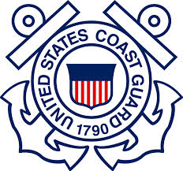
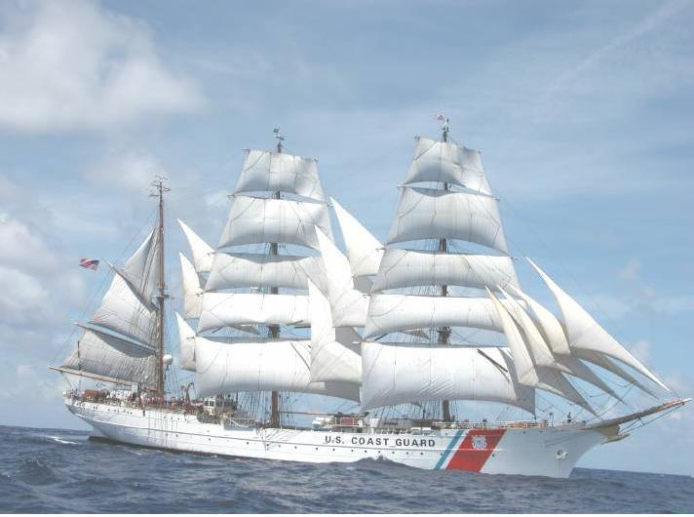
Friday, September 21, 2018
Social Hour 1730 Dinner 1830
Double Tree – Atlantic Beach
Dinner Selections:
Scottish Baked Salmon Fillet with a Red Pepper Coulis

Herb Roasted Chicken Breast with a Marsala Wine Sauce

Broiled and Sliced NY Strip with a Shallot Demi Reduction

Vegetarian choice provided upon request with parmesan herb roasted red bliss potatoes and julienned vegetable medley

Hotel Information:
$129/night (use code: CGB) rooms reserved until 07 Sep

E-6 and Below $40 Retirees and Aux $45
GS9 and Below$45 E-7 to O-3 $50 GS10 and Above $55
O-4 and Above $65
Last Day to Purchase: Friday, 14 September 2018
Military Attire:
O4 & Above – Dinner Dress White Jacket (Optional for all others)

O3 & Below – Dinner Dress Blue

Civilian Attire – Formal Evening Wear

*OPTION: CG mbr to mbr; one in uniform & one in formal attire. All other branches; both in uniform.

For Tickets Contact:
SMTC:
BMCM Don Miterko
HSCS Shawn Meyer
BMC Shawn Wood

Fort Macon:
LTJG Jessica Tull
BMCS Carter Seigh
YNC Russell Romig

Wilmington:
ENS Michael Long
MSTC Jeremy Thomas
(meal selection made at time of purchase)

