So, here is some important info regarding registering for ICS-400.

First, ICS-300 is a pre-requisite. More about that later.

Assuming this is your first time logging into the NY State Learning System here is the roadmap to register for ICS-400. I

1. <https://nyslearn.ny.gov/index.html>
2. Click on the menu option :First Time Logging in.

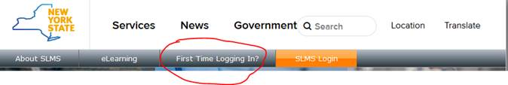

1. Scroll down and click on the [SLMS Partner User Registration Page](https://nyslearn.ny.gov/psp/pext/EMPLOYEE/ELM/c/NY_LM_CUSTOM.NY_ADD_EXTRNL_USR.GBL?FolderPath=PORTAL_ROOT_OBJECT.CO_ENTERPRISE_LEARNING.NY_HRADMINISTRATION.NY_ADD_EXTRNL_USR&IsFolder=false&IgnoreParamTempl=FolderPath%2cIsFolder)
2. Click the “Other” Check box. This will bring up the sign up data entry screen.
3. Fill in your name, address, etc. but in the “Affiliation” box type the word “other” and a hidden box will pop up. (see below)

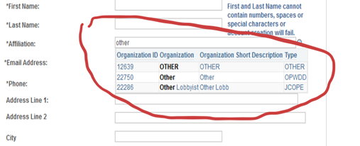

1. Select 12639 OTHER with your mouse.
2. Click on Submit – you will be sent to the sign in page and an email will be sent to you with instructions.
3. Check your email for mail from [DoNotReply.SLMS@its.ny.gov](mailto:DoNotReply.SLMS@its.ny.gov). The email contains your user id and password.
4. Once you have you username and password sorted out go back to the sign-in page at <https://my.ny.gov/> and sign in.
5. Scroll down to the **teal** banner that says “You can sign up for the following services”
6. Click on the SLMS tile (top left)
7. Click on “find learning”
8. Enter “I 400” in the search box….. I Space 400….. No dashes

cid:image010.png@01D4ADB3.7CD6A520

1. Click on the double right arrow.
2. Scroll through the search results to find the Brooklyn class on 4/25. Note there is same offered in Riverhead June 19th. (I signed up for that one)
3. Click on Enroll.
4. In case you need the ICS 300 search for I 300 same as we did I 400.