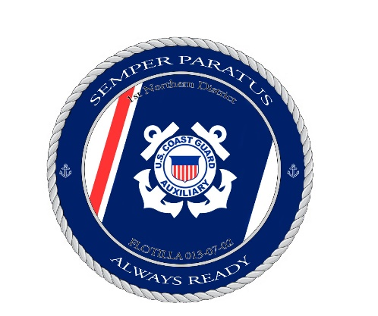
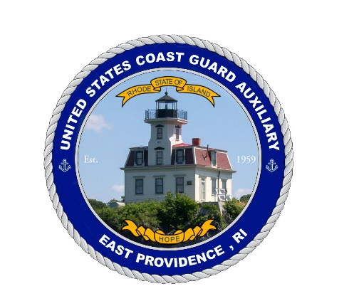
U.S.C.G. Auxiliary
Flotilla 72 – 1st Northern Region
The East Providence Flotilla
Awards History

– Denotes Distinguished Awards
– 1995 –
- Division 7 Plaque: Most Outstanding Flotilla in Division 7, 1 NR.
- National Certificate: Auxiliary Mission Objective System (AMOS) Award for meeting goals in
the following areas: Member Resources, Vessel Examinations,
Operations and Public Education.

– 1996 –
- Division 7 Plaque: Most Outstanding Flotilla in Division 7, 1 NR.

– 1997 –
- Division 7 Plaque: Most Outstanding Flotilla in Division 7, 1 NR.

– 1998 –
- Division 7 Plaque: Most Outstanding Flotilla in Division 7, 1 NR.

- District Plaque: Most Outstanding Flotilla in 1st NR District.

- District Plaque: 3rd Place for Most Public Affairs Missions (86) in 1st NR District.

– 1999 –
- Division 7 Plaque: Most Outstanding Flotilla in Division 7, 1 NR.

- District Plaque: Most Outstanding Flotilla in 1st NR District.

- District Commander’s Plaque: Most Outstanding Flotilla in 1st NR District.

- Commodore R. Foster Reynold’s Plaque: Most Improved Flotilla in 1st NR District.
– 2000 –
- Division 7 Plaque: Most Outstanding Flotilla in Division 7, 1 NR.

- District Plaque: Most Outstanding Flotilla in 1st NR District.

- District Plaque: 3rd Place for Most Marine Dealer Visits (128 Visits) in 1st NR District.

– 2001 –
- Division 7 Plaque: Most Outstanding Flotilla in Division 7, 1 NR.

- District Plaque: Most Outstanding Flotilla in 1st NR District.

- District Plaque: 3rd Place for Most Marine Dealer Visits (127 Visits) in 1st NR District.

– 2002 –
- District Plaque: 2nd Place for Most RBS Partner Visits (76 Visits) in 1st NR District.

– 2004 –
- Division 7 Plaque: Most Outstanding Public Affairs Missions (96) in Division 7, 1 NR.

- District Plaque: 1st Place for Most RBS Partner Visits (277 Visits) in 1st NR District.

- District Plaque: 1st Place for Most Public Affairs Hours (199) in 1st NR District.
- National Certificate: National Achievement as one of the top 100 performers in the RBS
Partner Visitation program.

– 2005 –
- Division 7 Plaque: Most Outstanding Public Affairs Missions (71) in Division 7, 1 NR.

- District Plaque: Most Outstanding RBS Partner Visits (222 Visits) in 1st NR District.

– 2006 –
- Division 7 Plaque: Most Outstanding Public Affairs Missions (85) in Division 7, 1 NR.

- District Plaque: Most Outstanding RBS Partner Visits (395 Visits) in 1st NR District.

- Awarded our 1st Flotilla Meritorious Achievement Ribbon
– 2007 –
- Division 7 Plaque: Most Outstanding Public Affairs Missions (60) in Division 7, 1 NR.

- District Plaque: Most Outstanding RBS Partner Visits (449 Visits) in 1st NR District.

– 2008 –
- Division 7 Certificate: Most Outstanding Public Affairs Missions (50) in Division 7, 1 NR.

- District Plaque: Most Outstanding RBS Partner Visits (395 Visits) in 1st NR District.

- District Plaque: Most Outstanding Flotilla in 1st NR District.

– 2009 –
- Division 7 Certificate: Most Outstanding Public Affairs Missions (62) in Division 7, 1 NR.

- District Plaque: Most Outstanding RBS Partner Visits (456 Visits) in 1st NR District.

- National Certificate: National Commodore’s Certificate of Achievement Award for Fifty
Years of Service from 10 FEB 1959 to 10 FEB 2009.

– 2010 –
- Division 7 Certificate: Most Recruited New Members (10) in Division 7, 1 NR.

– 2011 –
- District Plaque: 1st Place Most RBS Partner Visits (443 Visits) in 1st NR District.

– 2012 –
- District Plaque: 1st Place Best Flotilla Newsletter in 1st NR District.

– 2014 –
- Division 7 Certificate: Most Recruited New Members (9) in Division 7, 1 NR.

– 2016 –
- District Plaque: 1st Place Best Flotilla Newsletter in 1st NR District.
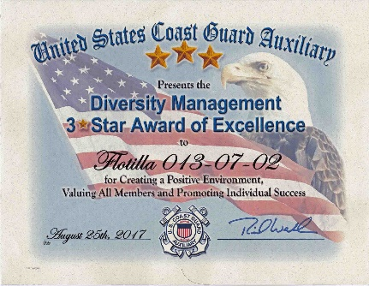
– 2017 –
- 1st Certificate: Diversity Management Three Star Award of Excellence.

– 2018 –
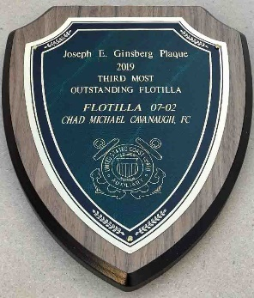
- District Plaque: 1st Place Best Flotilla Newsletter in 1st NR District.

– 2019 –
- District Plaque: 3rd Place Most Outstanding Flotilla in 1st NR District.

- 2nd Certificate: Diversity Management Three Star Award of Excellence.

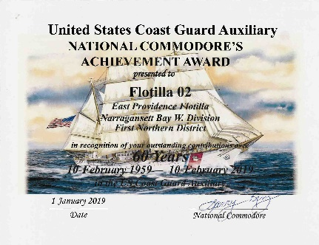
- National Certificate: National Commodore’s Certificate of Achievement Award for Sixty
Years of Service from 10 FEB 1959 to 10 FEB 2019.
- Proclamation from City of East Providence for our 60th Anniversary.

– 2020 –
- 3rd Certificate: Diversity Management Three Star Award of Excellence.

– 2021 –
- Division 7 Certificate: Most Outstanding Public Affairs (90.36 hrs) in Division 7, 1 NR.
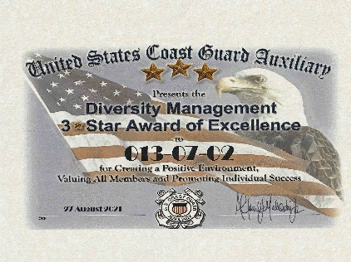
- 4th Certificate: Diversity Management Three Star Award of Excellence.

– 2022 –
- 5th Certificate: Diversity Management Three Star Award of Excellence.
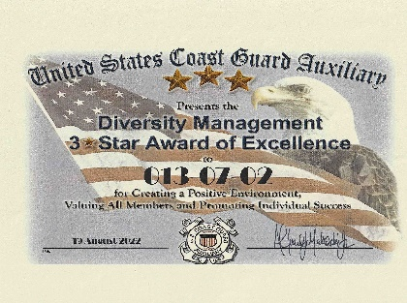

– 2023 –

